DECEMBER 1999

STATE OF CALIFORNIA
AIR RESOURCES BOARD

STANDARD OPERATING PROCEDURE FOR THE CERTIFICATION OF CALIBRATION AND AUDIT GAS STANDARDS

MLD METHOD 5722

STANDARDS LABORATORY
PROGRAM EVALUATION AND STANDARDS SECTION
QUALITY MANAGEMENT AND OPERATIONS SUPPORT BRANCH
MONITORING AND LABORATORY DIVISION
1927 13th STREET
SACRAMENTO, CA 95814

TABLE OF CONTENTS

Page Number

1. INTRODUCTION 1
2. SUMMARY OF METHOD 3
2.1 METHOD NOMENCLATURE 3
2.2 ANALYSIS METHOD 4

3. INTERFERENCES AND LIMITATIONS 6

4. INSTRUMENTATION AND EQUIPMENT 7
  - BALANCE SETUP 7
  - AMBIENT GAS SETUP 8
  - SOURCE GAS SETUP 12
  - LIST OF GAS STANDARDS 16

5. AMBIENT GAS CYLINDER CERTIFICATION PROCEDURE 20
5.1 ANALYZER CALIBRATION PROCEDURE 20
5.2 GAS CYLINDER SETUP 21
5.3 SELECTION OF LABORATORY STANDARD 25
5.4 GAS CERTIFICATION PROCEDURE 27
5.5 SULFUR DIOXIDE PERMEATION TUBE ASSAY PROCEDURE 30

6. SOURCE GAS CYLINDER CERTIFICATION PROCEDURE 33
6.1 ANALYZER CALIBRATION PROCEDURE 33
6.2 GAS CYLINDER SETUP 34
6.3 SELECTION OF LABORATORY STANDARD 37
6.4 GAS CERTIFICATION PROCEDURE 38

7. MASS FLOW CONTROLLER CERTIFICATION PROCEDURE 41
7.1 AMBIENT 200 CCM MASS FLOW CONTROLLER (MFC #1) SETUP 41
7.2 AMBIENT 30 LPM MASS FLOW CONTROLLER (MFC #2) SETUP 44
7.3 AMBIENT 10 LPM MASS FLOW CONTROLLER (MFC #3) SETUP 45
7.4 SOURCE 30 LPM MASS FLOW CONTROLLER (MFC #5) SETUP 47
7.5 SOURCE 200 CCM MASS FLOW CONTROLLER (MFC #6) SETUP 48
7.6 SOURCE 50 CCM MASS FLOW CONTROLLER (MFC #7) SETUP 49
7.7 MASS FLOW CONTROLLER CALIBRATION PROCEDURE 51

- BACKUP ZERO AIR SUPPLY IMPLEMENTATION PROCEDURE 57
8.1 PLACING BACKUP ZERO AIR SUPPLY IN SERVICE. 57
  - REMOVING BACKUP ZERO AIR SUPPLY FROM SERVICE. 58
- QUALITY CONTROL PRACTICE 58
  - DAILY PRACTICES 58
  - BIWEEKLY PRACTICES 69
  - MONTHLY PRACTICES 60
  - QUARTERLY PRACTICES 60
  - ANNUAL PRACTICES 60
  - BIENNIAL PRACTICES 62

- REFERENCES 69

APPENDIX A DATASHEETS
A.1 AMBIENT GAS SETUP SHEET A-2
A.2 SOURCE GAS SETUP SHEET A-3
A.3 DAILY BALANCE DATA SHEET A-4
A.4 PERMEATION TUBE DATA SHEET A-5

LIST OF FIGURES

Page Number

Figure 1. Schematic of dilution analysis. 4
Figure 2. Schematic of direct injection analysis. 5
Figure 3. Picture of Balance setup. 8
Figure 4. Picture inside Ambient Dilution Box (MFCs #1 and #2). 9
Figure 5. Picture of ambient MFC#3. 9
Figure 6. Picture of ambient MFC control panel. 10
Figure 7. Picture of Ambient control panel. 11
Figure 8. Picture of Ambient GAS instrument rack. 12
Figure 9. Picture of source MFCs. 13
Figure 10. Picture of source MFC control panel. 13
Figure 11. Picture of Source control panel. 15
Figure 12. Picture of Source GAS instrument rack. 15
Figure 13. Illustration of cutting Teflon strip. 22
Figure 14. Illustration of Teflon strip placement. 23
Figure 15. Detail illustration of water bath. 31
Figure 16. Picture of Ambient Dilution Box. 42
Figure 17. Picture of gray output post in flow room. 43
Figure 18. Side view of Source Dilution Box. 45
Figure 19. Picture of gray output post next to fume hood. 46
Figure 20. Picture of Source Dilution Box. 48
Figure 21. Picture showing location of house air cutout valve. 58
Figure 22. Picture showing location of instrument rack two-way valve. 58
Figure 23. Picture of inlet tee to thermal oxidizer. 61

- INTRODUCTION

This Standard Operating Procedure (SOP) outlines the procedures used by the Standards Laboratory staff for assaying the concentration of compressed gas calibration and audit standards and for certifying the assayed concentrations as traceable to a Nation Institute of Standards and Technology (NIST) Standard Reference Material (SRM). The Standards Laboratory is capable of assaying nitrogen oxide and oxides of nitrogen (NO/NO_{x}), sulfur dioxide (SO₂), carbon monoxide (CO), methane (CH₄), non-methane hydrocarbons (NMHC), hydrogen sulfide (H₂S), propane (C₃H₈), carbon dioxide (CO₂), and oxygen (O₂). 40 CFR Parts 50, 58, 60, and 75 require the use of the EPA protocol defined in “EPA TRACEABILITY PROTOCOL FOR ASSAY AND CERTIFICATION OF COMPRESSED GAS CALIBRATION STANDARDS”¹ for certifying compressed gases for the calibration and audit of ambient air quality analyzers and continuous emission monitors. This SOP is the very same as the EPA’s protocol, in most respects. In a few areas, the SOP differs from the traceability protocol in terms of procedure. In these areas, the SOP meets the intent and performance criteria of the protocol.

This SOP uses a peer-reviewed analytical procedure based on the U.S. EPA’s Traceability Protocol. A letter outlining the differences was sent to the U.S. EPA for review in December 1988. A technical paper describing the protocol was presented at the Air & Waste Management Association’s 86th Annual Meeting in June 1993. The paper underwent external peer review by Shawn Kendall of Phelps Dodge Corporation prior to presentation.

The major difference between the ARB and U.S. EPA protocols is the U.S. EPA allows secondary standards to be certified utilizing a non-dilution method only. This SOP uses a method utilizing dilution of both primary SRMs and secondary standards. Whenever possible, the concentrations (via dilution) of the primary and secondary standards are match to be within 5 percent, so that the flow through the mass flow controllers remains unchanged during the dilution of both primary and secondary standards. However, there are occasions where it is not possible to match primary and secondary standard concentrations. The mismatched standards situations are where the Standards Laboratory observes its lowest accuracy and precision. These types of “worst case” situations are where the analytical accuracy and precision are determined.

This SOP tends to be more restrictive than the EPA protocol on the other differences. The differences include:

Analyzer calibration periodicity - The EPA protocol calls for monthly calibrations of each analyzer and allows for corrections based upon daily spans. This procedure performs analyzer calibrations prior to each assay.
Comparisons to Standards - The EPA protocol requires three comparisons to an SRM or Gas Manufacturer Intermediate Standard (GMIS); the three comparisons may occur in sequence in one day. This protocol performs the three comparisons on three separate days.
GMIS stability - The EPA protocol requires GMISs to be assayed three times over a three-month period. The intent of this is to ensure the manufacturer allows sufficient time for the gas to stabilize in the cylinder. All the cylinders assayed under this protocol are several months old and have been demonstrated to be stable.
Uncertainty calculation - The EPA protocol provides information to calculate the uncertainty (precision) of each cylinder. The Standards Laboratory provides precision information on the total uncertainty for each type of gas assayed, based upon the control limits allowed by the EPA protocol and the uncertainty of the SRMs. The total uncertainty for all gases except H₂S is +/- 3.0 percent, H₂S being
+/- 3.4 percent.

2. SUMMARY OF METHOD

  - METHOD NOMENCLATURE

    - Certification – establishes traceability of a calibration or audit gas standard to a NIST SRM. The certification of a gas standard requires the results of 3 valid assays be less than 1 percent relative standard deviation. The certified gas concentration is the average of the three valid assays. Assaying the gas standard three times ensures the gas stability.

    - Dilution – a process of mixing a compressed gas cylinder with pure air to achieve concentration levels measureable by an analyzer. The concentration of the compressed gas and the operating range of the analyzer dictates the required amount of dilution required to accurately and precisely assay a gas.

    - Direct injection – a process of assaying a compressed gas cylinder by applying the gas directly (not via dilution) into the sample port of an analyzer. The concentration of the compressed gas must be within the operating range of the analyzer.

    - Primary Standard – a NIST Standard Reference Material (SRM) or NIST Traceable Reference Material (NTRM). Material considered to be of the highest accuracy, purity, and quality.

    - Secondary Standard – a Gas Manufacturer Intermediate Standard (GMIS) or laboratory standard that has been assayed and certified directly to a primary standard.

    - Tertiary Standard – a guest cylinder that has been assayed and certified directly to a secondary standard. By definition, these cylinders are traceable to a NIST SRM.

    - Traceable Standard – One that has been compared and certified, either directly or via not more than one intermediate standard, to a primary standard such as a NIST SRM or an NTRM.

  - ANALYSIS METHOD

    - Each analyzer is calibrated using either primary or secondary standards, pure air, and certifed mass flow controllers (MFCs) at four concentrations evenly spread through the analyzer’s operating range.

Figure 1. Schematic of dilution analysis.
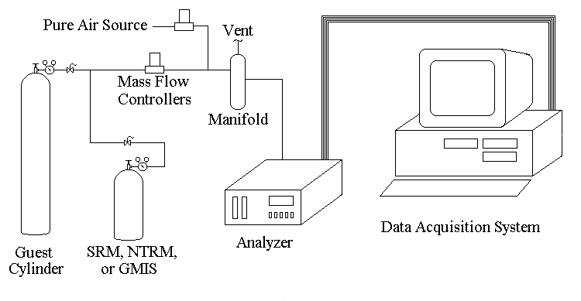
    - All analyzers except the ambient CO and CH₄/NMHC analyzers are calibrated via dilution. The ambient CO and CH₄/NMHC analyzers are calibrated via direct injection.

    - The gas from each guest instrument is then diluted to a level within the operating range of the analyzer.

    - The measured value is multiplied by the amount of dilution required for step 2.2.3 to achieve an assayed value.

    - Each cylinder is assayed at least three times. In order to show gas stability, the relative standard deviation of the three assays must be less than 1%.

    - Traceability is established since a secondary standard is assayed by an analyzer calibrated by a primary standard. A tertiary standard is assayed by an analyzer calibrated by a secondary standard. By definition, the secondary and tertiary standards exhibit traceability to a NIST SRM or NTRM.

    - The Gas Analysis System (GAS) is separated into two separate systems, the ambient GAS and source GAS. The source GAS analyzes single compound gases and they tend to be at higher concentrations. The source GAS assays calibration gas for source emission testing. The ambient GAS analyzers single or multiple blended compound gases and they ten to be at lower concentrations. The ambient GAS assays calibration and audit gas for ambient monitoring.

    - The calibration gas for the ambient SO₂ and H₂S analyzers is permeation tube. The gas from the permeation tube is diluted with pure air to levels measureable by the ambient SO₂ and H₂S analyzers.

    - H₂S is measured indirectly by a SO₂ analyzer. The sample gas is introduced to a thermal oxidizer that converts H₂S to SO₂. The efficiency of the thermal oxidizer is checked annually. See step 9.5.1.

    - The ambient CO and CH₄/NMHC analyzers are calibrated via direct injection. Four cylinders containing different levels of blended CO and CH₄, or CO and C₃H₈, are used to calibrate the analyzers. CO and CH₄/NMHC gas can be then assayed via dilution or direct injection.

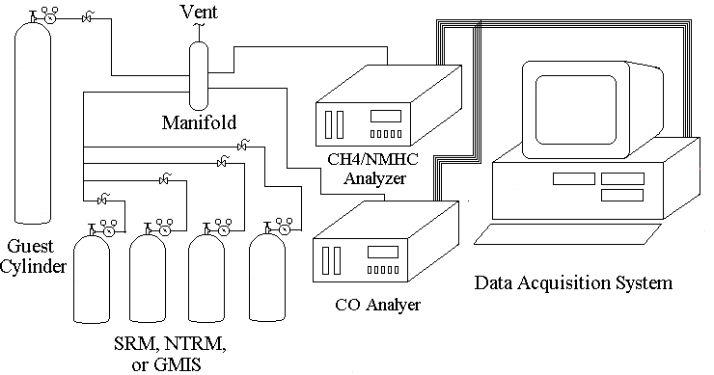
Figure 2 Schematic of direct injection analysis.
    - The source O₂ analyzer is calibrated using a pure oxygen cylinder (99.999% pure) diluted with Grade 5 nitrogen. Guest O₂ cylinders are assayed via direct injection by the O₂ analyzer.

- INTERFERENCES AND LIMITATIONS

  - Mass flow meters (MFMs) use the thermal properties of a gas to determine the flow rate. Essentially, MFMs measure a gas’s ability to remove heat from a metal surface. The rate of heat removal is used to determine the mass flow rate of a gas. Each gas has a unique specific heat capacity or ability to absorb heat. A gas with a lower specific heat capacity will display a lower flow on a MFM than a gas with higher specific heat capacity because it does not remove heat as well as the second gas, even though the two gases are at identical flow rates. The difference in the flow rates is directly proportional to the concentration of the gas. As the concentration of the gas increases, its measured flow rate decreases, even though its actual flow rate remains unchanged. To account for this, a gas correction factor is determined for each gas to correct the displayed flow rate. Correction factors for hydrocarbons (methane and propane) and carbon dioxide are determined biennially. Previous evaluations have showed that correction factors for NO, CO, SO₂, O₂ and air are negligible; their correction factors are very close to that of nitrogen. Step 9.5.2 outlines the procedure for determining a gas’s correction factor. Historically, each gas’s correction factor has not change, but it is recalculated biennially to ensure that it is still representative of the gas.

  - Dasibi 4108 SO₂ analyzers have shown to experience interference in analyzing SO₂ concentrations in the presence of NO. The exact mechanism for the interference is unknown, but the result is predictable. As the concentration of NO increases, the measured concentration of SO₂ decreases, even though the SO₂ concentration remains unchanged. Some of the cylinders assayed by the Standards Laboratory contain blended gases of NO and SO₂. Therefore, the measured SO₂ concentration must be adjusted based on the NO concentration. Step 9.5.3 outlines the procedure for determining the correction factor for measuring SO₂ blended with NO.

  - The ambient SO₂ analyzer is calibrated using gas from permeation tubes. There exist some line losses between the permeation tube water bath and the SO₂ analyzer. The exact mechanism for the loss is not clear, but the loss can be accounted for. After the analyzer is calibrated using the permeation tube’s gas, a SO₂ lab standard is assayed. The difference from the assayed value and its certified value is the line loss. The line loss can then be applied to the assayed value of all guest cylinders containing SO₂. Staff have taken measures to minimize the line loss by using stainless steel lines instead of Teflon where possible and use smaller diameter lines to minimize time gas exposed to Teflon. It has been proposed that SO₂ readily permeates through Teflon, since permeation tubes are made of Teflon. However, the line loss has been minimized but not eliminated. Staff intends to continue to replace all the Teflon lines and connections associated with the calibration and assaying sample lines with stainless steel to further minimize the line loss. The line loss correction is setup in step 5.2.10.

- INSTRUMENTATION AND EQUIPMENT

  - BALANCE SETUP

    - Calibrated Balance.

    - Certified Weight – Control Standard.

    - Controlled Environmental Chamber – humidity controlled.

Figure 3. Picture of Balance setup.
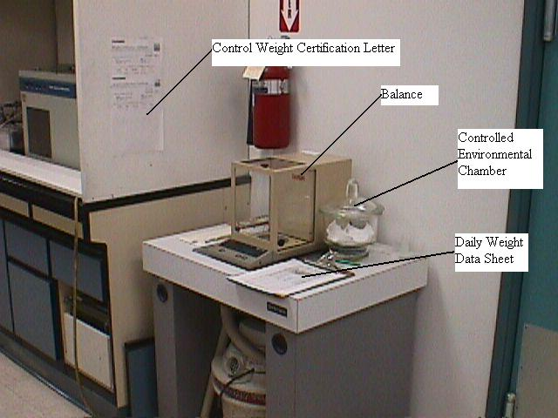
  - AMBIENT GAS SETUP

    - Analyzer ranges and MFC sizes are selected to assay the following compressed cylinder concentrations:

      - NO/NO_{x} 3 to 1080 ppm.

      - CO 7.5 to 45 ppm via direct injection.
150 to 54,000 ppm via dilution.

      - CH₄ 3 to 18 ppm via direct injection.
60 to 21,600 ppm via dilution.

      - C3H8 (NMHC) 1.5 to 9 ppmC via direct injection.
30 to 10,800 ppmC via dilution.

      - SO₂ 1.5 to 540 ppm.

      - H₂S 1.5 to 540 ppm.

    - Ultra-pure air source.

    - Three mass flow controllers (MFCs).

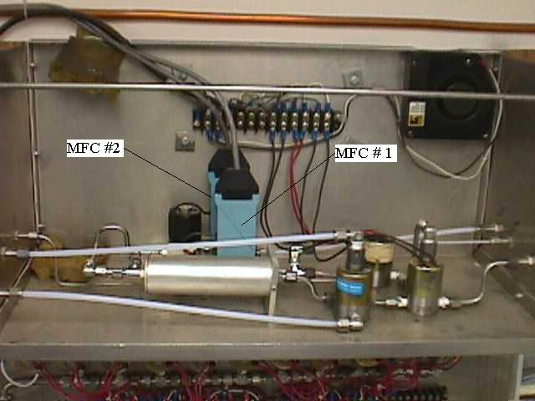
Figure 4. Picture inside Ambient Dilution Box (MFCs #1 and #2).

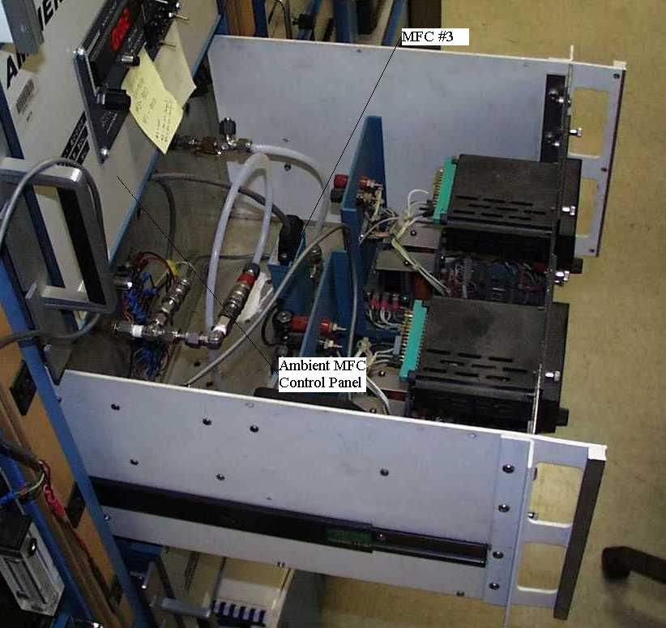
Figure 5. Picture of ambient MFC#3 (located inside black control panel on Ambient GAS rack, below ambient MFC control panel).

      - One 200 cm³/minute (CCM) MFC.

      - One 30 liter/minute (LPM) MFC.

      - One 10 LPM MFC.

    - MFC Control Panel.

Figure 6. Picture of ambient MFC control panel.
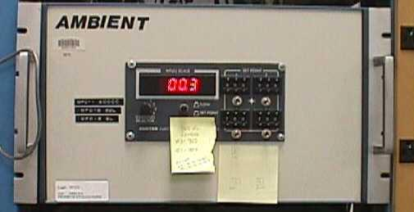
    - One NO/NO_{x} analyzer – TECO 42.

      - Analyzer capable of achieving the following ranges: 0 to 50 ppb, 100 ppb, 200 ppb, 1 ppm, 2 ppm, 5 ppm, 10 ppm, and 20 ppm. Default setting is 0 to 1 ppm.

    - One CO analyzer – TECO 48.

      - Analyzer capable of achieving the following ranges: 0 to 1 ppm, 2 ppm, 5 ppm, 10 ppm, 20 ppm, 50 ppm, 100 ppm, 200 ppm, 500 ppm, and 1000 ppm. Default setting is 0 to 50 ppm.

    - One CH₄/NMHC analyzer – TECO 55.

      - Analyzer capable of achieving the following ranges: 0 to 10 ppmC, 100 ppmC, and 1000 ppmC. Default settings are 0 to 100 ppmC (recorder range is 0 to 20 ppmC) for CH₄ and 0 to 10 ppmC for NMHC.

    - Two SO₂ analyzers – Dasibi 4108. One will analyze SO₂ directly. The other will analyze H₂S indirectly through a thermal oxidizer. The thermal oxidizer converts all H₂S to SO₂.

      - Analyzer capable of achieving the following ranges: 0 to 0.5 ppm, 2 ppm, 5 ppm, and 20 ppm. Default setting is 0 to 0.5 ppm.

    - One thermal oxidizer – Graseby/STI.

      - Operating range of thermal oxidizer: 1400 to 1800 degrees Celsius. Default setting for analyzing H₂S is 1755 degrees Celsius, 1400 degrees Celsius when not analyzing H₂S.

    - One H₂S analyzer - Atlas.

      - Analyzer capable of achieving the following range: 0 to 1 ppm.

    - One chart recorder – Yokogawa.

      - Chart recorder capable of reading up to 20 channels, 10 volts DC.

    - One control panel – manufactured by ARB staff.

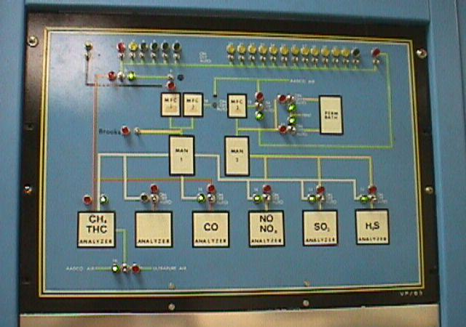
Figure 7. Picture of Ambient control panel.

    - One water bath – Forma Scientific 2095.

      - Normal operating temperature: 25 degrees Celcius, +/- 1 degree.

    - One Metra-byte data acquisition system and associated solenoids.

      - Capable of operating up to 96 control relays, 8 digital-to-analog converters capable of outputting 0 to 5 volts DC, 32 analog-to-digital converters capable of reading 0 to 10 volts DC.

    - One computer workstation.

      - PC-based computer system with associated GAS software and Metra-byte ISA controller card.

    - One hydrogen generator – Elgen MK V.

      - Capable of supplying 300 ccm of 99.999% pure hydrogen gas.

    - Display of Ambient GAS instrument rack.

Figure 8. Picture of Ambient GAS instrument rack.
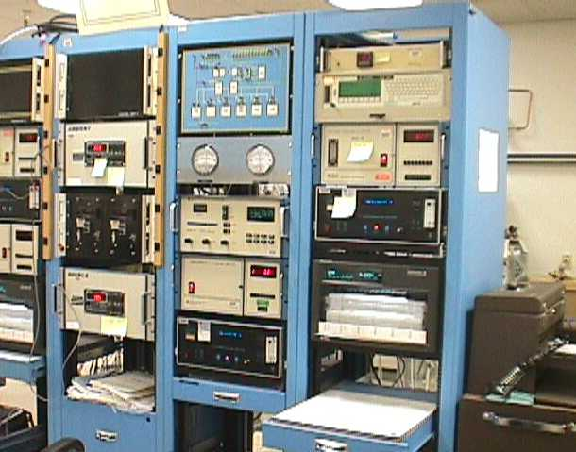
  - SOURCE GAS SETUP

4.3.1 Analyzer ranges and MFC sizes are selected to assay the following compressed cylinder concentrations:

      - NO/NO_{x} 15 to 21,600 ppm.

      - CO 3 to 999,999 ppm (100 %).

      - CH₄ 30 to 1,000,000 ppm (100 %).

      - C3H8 (NMHC) 10 to 400,300 ppm.

      - SO₂ 1.5 to 21,600 ppm.

      - O₂ 31 to 225,000 ppm.

      - CO₂ 15 to 1,000,000 ppm (100 %).

    - Ultra-pure air source.

    - Three MFCs.

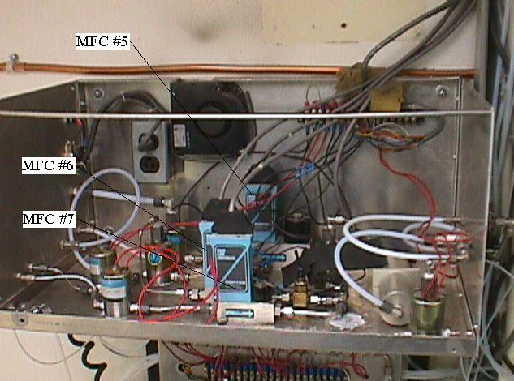
Figure 9. Picture of source MFCs.

      - One 30 LPM MFC.

      - One 200 CCM MFC.

      - One 50 CCM MFC.

    - MFC Control Panel.

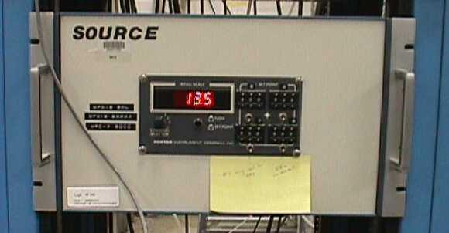
Figure 10. Picture of source MFC control panel.
    - One NO/NO_{x} analyzer – TECO 42.

      - Analyzer capable of achieving the following ranges: 0 to 50 ppb, 100 ppb, 200 ppb, 1 ppm, 2 ppm, 5 ppm, 10 ppm, and 20 ppm.

    - One CO analyzer – TECO 48.

      - Analyzer capable of achieving the following ranges: 0 to 1 ppm, 2 ppm, 5 ppm, 10 ppm, 20 ppm, 50 ppm, 100 ppm, 200 ppm, 500 ppm, and 1000 ppm.

    - One CH₄/NMHC analyzer – TECO 55.

      - Analyzer capable of achieving the following ranges: 0 to 10 ppmC, 100 ppmC, and 1000 ppmC.

    - One SO₂ analyzer – Dasibi 4108.

      - Analyzer capable of achieving the following ranges: 0 to 0.5 ppm, 2 ppm, 5 ppm, and 20 ppm.

    - One CO₂ analyzer – TECO 41H.

      - Analyzer capable of achieving the following ranges: 0 to 5 ppm, 10 ppm, 20 ppm, 50 ppm, 100 ppm, 200 ppm, 500 ppm, 1000 ppm, 2000 ppm, and 5000 ppm.

    - One O₂ analyzer – Rosemont Analytical 755R.

      - Analyzer capable of achieving the following range: 0 to 25 % (250000 ppm).

    - One chart recorder – Yokogawa.

      - Chart recorder capable of reading up to 20 channels, 10 volts DC.

    - One control panel – manufactured by ARB staff.

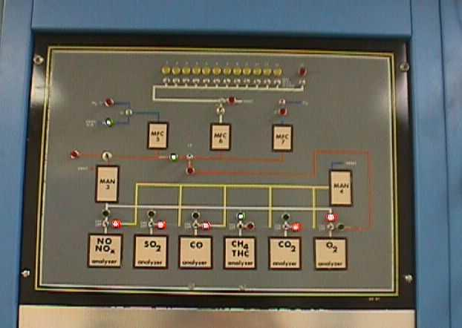
Figure 11. Picture of Source control panel.

    - Display of Source GAS instrument rack.

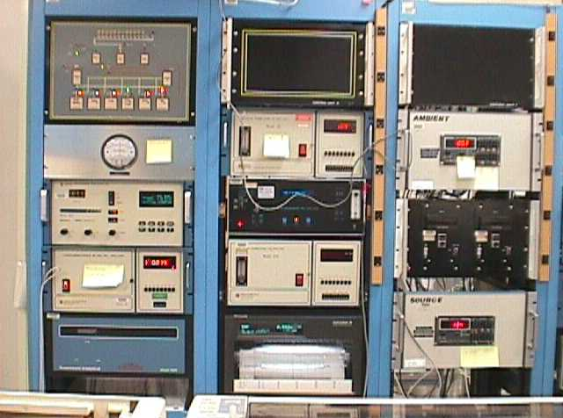
Figure 12. Picture of Source GAS instrument rack.

  - LIST OF GAS STANDARDS

    - The following are nominal concentrations. Exact concentrations are determined by NIST. Most SRMs are available, except for those noted as special orders. They are not normally manufactured by NIST and require a significant amount of time to fill the order. Allow 6 months to 2 years time for NIST to fill special orders.

    - NIST CO SRMs.

      - 6 ppm CO in air. Special order.

      - 10 ppm CO in air.

      - 20 ppm CO in air.

      - 45 ppm CO in air.

      - 100 ppm CO in nitrogen.

      - 500 ppm CO in nitrogen.

      - 5000 ppm CO in nitrogen.

    - CO Laboratory Standards.

      - 7.5 ppm CO in air, could be blended with either 1.5 ppmC propane laboratory standard or 3 ppm methane laboratory standard.

      - 20 ppm CO in air, could be blended with either 4 ppmC propane laboratory standard or 8 ppm methane laboratory standard.

      - 32.5 ppm CO in air, could be blended with either 6.5 ppmC propane laboratory standard or 13 ppm methane standard.

      - 45 ppm CO in air, could be blended with either 9 ppmC propane laboratory standard or 18 ppm methane laboratory standard.

      - 100 ppm CO in air.

      - 1000 ppm CO in air.

      - 2000 ppm CO in air.

      - 7500 ppm CO in nitrogen.

    - NIST NO SRMs.

      - 50 ppm NO in nitrogen.

      - 100 ppm NO in nitrogen.

      - 500 ppm NO in nitrogen.

    - NO Laboratory Standards.

      - 50 ppm NO in nitrogen.

      - 100 ppm NO in nitrogen.

      - 500 ppm NO in nitrogen.

    - NIST SO₂ SRMs.

      - 50 ppm SO₂ in nitrogen.

      - 100 ppm SO₂ in nitrogen.

      - 1000 ppm SO₂ in nitrogen.

      - 10 cm SO₂ permeation tube. Permeation rate: 2.6 μg/min at 25 degrees C.

    - SO₂ Laboratory Standards.

      - 56 ppm SO₂ in nitrogen.

      - 100 ppm SO₂ in nitrogen.

      - 500 ppm SO₂ in nitrogen.

      - 1000 ppm SO₂ in nitrogen.

    - NIST H₂S SRMs.

      - 20 ppm H₂S in nitrogen.

      - 300 ppm H₂S in nitrogen. Special order.

    - H₂S Laboratory Standards.

      - 20 ppm H₂S in nitrogen.

    - NIST CO₂ SRMs.

      - 4 % (40,000 ppm) CO₂ in nitrogen.

      - 16 % (160,000 ppm) CO₂ in nitrogen.

    - CO₂ Laboratory Standards.

      - 4 % (40,000 ppm) CO₂ in nitrogen.

      - 11 % (110,000 ppm) CO₂ in nitrogen.

    - NIST CH₄ SRMs.

      - 1 ppm CH₄ in air.

      - 4 ppm CH₄ in air.

      - 10 ppm CH₄ in air.

      - 18 ppm CH₄ in air.

      - 45 ppm CH₄ in air.

      - 4 % (40,000 ppm) CH₄ in nitrogen.

    - CH₄ Laboratory Standards.

      - 3 ppm CH₄ in air, may be blended with 7.5 ppm CO laboratory standard.

      - 8 ppm CH₄ in air, may be blended with 20 ppm CO laboratory standard.

      - 13 ppm CH₄ in air, may be blended with 32.5 ppm CO laboratory standard.

      - 18 ppm CH₄ in air, may be blended with 45 ppm CO laboratory standard.

      - 45 ppm CH₄ in air.

      - 1500 ppm CH₄ in air.

      - 2000 ppm CH₄ in nitrogen.

      - 4 % (40,000 ppm) CH₄ in nitrogen.

    - NIST C₃H₈ SRMs.

      - 1 ppm C₃H₈ in air.

      - 3 ppm C₃H₈ in air.

      - 100 ppm C₃H₈ in air.

      - 500 ppm C₃H₈ in air.

      - 2 % (20,000 ppm) C₃H₈ in nitrogen.

    - C₃H₈ Laboratory Standards.

      - 0.5 ppm C₃H₈ in air, may be blended with 7.5 ppm CO laboratory standard.

      - 1.3 ppm C₃H₈ in air, may be blended with 20 ppm CO laboratory standard.

      - 2.2 ppm C₃H₈ in air, may be blended with 32.5 ppm CO laboratory standard.

      - 3 ppm C₃H₈ in air, may be blended with 45 ppm CO laboratory standard.

      - 500 ppm C₃H₈ in air.

      - 2 % (20,000 ppm) C₃H₈ in nitrogen.

      - 4 % (40,000 ppm) C₃H₈ in nitrogen.

    - NIST O₂ SRMs.

      - 2 % (20,000 ppm) O₂ in nitrogen.

      - 10 % (100,000 ppm) O₂ in nitrogen.

      - 21 % (210,000 ppm) O₂ in nitrogen.

    - O₂ Laboratory Standard.

      - 99.999 % (999,990 ppm) O₂.

- AMBIENT GAS CYLINDER CERTIFICATION PROCEDURE

5.1 ANALYZER CALIBRATION PROCEDURE

    - Perform gas cylinder setup, step 5.2

    - Perform selection of gas standard, step 5.3

    - At the DOS prompt, type “Release”. Then press the Enter key.

    - At the DOS prompt, type ”STDLAB_S”. Then press the Enter key. This will map the required network drives.

    - At the DOS prompt, type “GASS”. Then press the Enter key

    - At the Gas Menu, type “AR” (type “BR” if running the Source Gas Analysis System simultaneously). Then press the Enter key.
    - Enter the number of runs you wish to perform for each gas system. Then press the Enter key. This feature allows multiple calibration runs to be performed in sequence. This feature is used mostly to perform calibrations over a weekend.

    - Enter “N” for No in the Continuous Run selection, then press the Enter key. If more than 1 was entered on previous step, entering “Y” will perform the runs one-after another. If more than 1 was entered on previous step, entering “N” will perform the runs on consecutive days starting at 16:00.

    - Enter “N” for No in the Print Results selection, then press the Enter key. Entering “Y” will print the results automatically (this is not recommended if performing more than one run per day).

    - Enter the time you wish to start the calibration run. Then press the Enter key.

    - If any of the gas standards or the MFC are out of certification, a warning screen will appear. The only warnings permissible to be discarded are “MFC certifications greater than 30 days”. All other warnings are to be heeded and the gas calibration procedure must be terminated.

    - Type “Q” and press the Enter key. This will bypass the purge program already performed in step 5.2.

    - Gas program is now running. Calibration will be completed in approximately 8 to 16 hours (longer for H₂S). When completed perform step 5.4.

  - GAS CYLINDER SETUP

    - Move guest cylinders in cylinder bays 20 through 31. If at least one of the cylinders contain SO₂, then do not fill bays 30 and 31. They will be used for a SO₂ lab standard and tracer.

5.2.1.1 WARNING! Securely fasten all cylinders using the safety chains or cylinder safety stands.

      - Remove all the cylinder caps and remove rubber band holding cylinder tags.

    - Using the appropriate type of regulator, attach regulators to all cylinders. Tighten regulator until securely fastened using large adjustable wrench. Use approximately 40 lbs. of force at end of wrench.
    - Open each cylinder valve slowly. Observe any audible sign of a leak. Immediately check for leaks using SNOOP LEAK DETECTOR.

      - If there is any sign of a leak, immediately close the cylinder valve. Vent the regulator using vent line located under Ambient Dilution Unit located on north wall.

      - If not able to stop leak by applying additional torque (up to 50 lbs. at end wrench) to regulator, remove regulator and try another regulator. Check for scores on Teflon seal. If any present, replace seal.

      - On metal to metal seal type regulators, cut a 2 inch strip of wide (1 inch) Teflon tape. Fold tape in half to form 1 inch square. Using scissors, cut a slit perpendicular into the fold. Unfold the Teflon tape.

Figure 13. Illustration of cutting Teflon strip.

      - Use Teflon tape to form seal on the regulator fitting that meets cylinder. Torque regulator. Open cylinder and check for leaks.

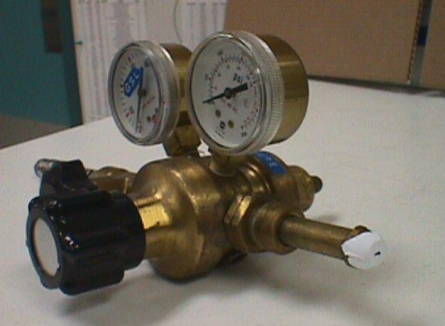
Figure 14. Illustration of Teflon strip placement.
      - If leaks still present, use a different regulator.

    - Connect Teflon gas line to regulator. Gas line is labeled and corresponds to bay number.

    - Run PURGE program to condition regulators with gas.

      - Use the gas computer to run purge program. Log onto computer using User Name and Password provided by network manager.

      - Using the mouse, press START, then RUN. Type in “COMMAND”, then press OK.

      - At the DOS prompt, type “PURGE”, then press the Enter key.

      - At Purge entry screen, press the Enter key to accept normal purge time. Type “C” for conditioning purge, then press the Enter key. Type “A” for the Ambient GAS, then press the Enter key.

      - Wait approximately 30 seconds, type the cylinder bay number to purge. Press the Enter key after entering the bay number. Continue entering bay numbers until completed. Then type cylinder bay “99” to start the purge program. Press the Enter key.

      - At Purge entry screen, type “Q” to quit. Press the Enter key. All regulators and lines are purged with each respective cylinder’s gas.

    - Using the Ambient Gas Data Sheet, enter appropriate data for each cylinder in cylinder bay 20 through 31.

    - At the DOS prompt, type “GASS”, then press the Enter key.

    - At the GAS menu, type “AE” (for Ambient GAS Setup), then press the Enter key.

    - Enter data onto from ambient gas datasheet onto computer. When all data entered, press the Ctrl and End key simultaneously.

    - If certifying a lab standard or guest cylinder containing SO₂, then enter the number of gas corrections required. Enter the number of corrections desired. For example, if you are attempting to certify a NO and CH₄ laboratory standard, then enter “2” on the input line. Otherwise, enter “0”.

      - Type the concentration of the gas standard you would like corrected to in the first field, then enter the numerical gas type in the second field. Put an “R” in the bay for which you want the gas corrected and an “S” in the bay that you want the guest cylinders corrected to. If entered correctly, type “Y” and press the Enter key.

    - At the gas menu screen, type “O” and press the Enter key.

    - Go to the standards menu by typing “S” and press the Enter key.

    - Check the ambient MFC’s calibration data by typing “AM” and press the Enter key.

      - Verify the slope and intercept for each mass flow controller are entered correctly, edit if necessary. Ensure each MFC was certified within the last 45 days. Obtain the data from the most recent ambient MFC calibration folder. Press the Ctrl and End keys simultaneously.

    - Go to the standards menu by typing “S” and press the Enter key.

    - Check the instrument ranges for the Ambient GAS by typing “AA” and pressing the Enter key.

    - Verify that the instrument ranges for each compound are set to their default values. The default values are: CH₄ – 20 ppm, NO – 1 ppm, SO₂ – 0.5 ppm,
CO – 50 ppm, and H₂S – 0.5 ppm. These values can be set to other settings if targeting other concentrations of guest cylinders. Use step 5.3 to determine alternate analyzer ranges. Edit values if necessary. Press the Ctrl and End keys simultaneously.

    - Go to the standards menu by typing “S” and press the Enter key.

    - Check the ambient gas standards by typing “AG” and press the Enter key.

    - Verify that the proper cylinders numbers and concentrations are entered for each gas standard. Use step 5.3 to determine alternate gas standards. Edit values if necessary. Press the Ctrl and End keys simultaneously.

    - Press the Esc key twice. The ambient gas system is now ready to start. Proceed to Gas Calibration Procedure, Step 6.1.

  - SELECTION OF LABORATORY STANDARDS

    - Laboratory standard certifications are valid for one year. Ensure each laboratory standard is within the certification period prior to use. To certify a laboratory standard, proceed to step 5.3.1.1. Otherwise, go to step 5.3.2.

      - Select a primary gas standard (NIST SRM) with a concentration within 5% of the laboratory standard’s concentration.

        - To certify the NO laboratory standard, place the NIST SRM chosen into the standards bay 1 and the secondary gas standard into bay 20 through 31. Enter the NIST SRM gas concentration at step 5.2.20.

        - To certify the four CO/CH₄ or CO/C₃H₈ gas standards, one of the two methods may be used. If there are no certified laboratory standards available, only the first method can be used.

          - Place four NIST SRMs containing CO in gas standards bay 4 through 7. Place the laboratory standards to be certified in bays 20 through 31. Enter the NIST SRM gas concentrations at step 5.2.20. After the CO portion of gas is certified, repeat using NIST SRMs containing CH₄ or C₃H₈.

          - Using 4 certified laboratory standards in gas standards bay 4 through 7, place the NIST SRMs in bays 20 through 31. Place the laboratory standards to be certified also in bay 20 through 31. Recalculate the gas standards to the NIST SRMs using step 5.2.10.

5.2.1.1.3 To certify SO₂ or H₂S, place the NIST SRM chosen into bay 20 through 31 and the secondary gas standard into bay 20 through 31 also. Using step 5.2.10, recalculate the secondary standard to the NIST SRM.

      - If the NIST SRM is assayed in bay 20 through 31, the secondary gas requires correction in step 5.2.10. Type the NIST SRM gas concentration in the first field, and place an “S” in the bay containing the NIST SRM. Type in an “R” in the bay containing the secondary gas standards. Ensure the proper gas type is selected in the second field.

    - Determine the highest and lowest concentration guest cylinder to certify.

      - For NO, the default analyzer range allows assaying gases between 3 and 1080 ppm NO. The default settings are 1 ppm analyzer range entered in step 5.2.17 and a secondary gas standard at approximately 100 ppm entered in step 5.2.20.

      - For SO₂ and H₂S, the default analyzer range allows assaying gases between 1.5 and 540 ppm. The default settings are 0.5 ppm analyzer range entered in setup 5.2.17. A NIST-SRM permeation tube gas standard of approximately 2.6 ppm entered in step 5.2.20. Secondary gas standard (used for correction due to system gas losses) and entered in step 5.2.12 of approximately 56 ppm for SO₂ and 300 ppm for H₂S (20 ppm may be substituted if closer to guest cylinder concentrations).

      - For CO, CH₄, and C₃H₈, the default analyzer range allows assaying gasses between 7.5 and 45 ppm CO, between 3.0 and 18 ppm CH₄, and 1.5 and 9.0 ppmC C₃H₈ via direct injection. Dilution may be used to assay gases between 150 - 54,000 ppm CO, 60 - 21,600 ppm CH₄, and 30 - 10,800 ppmC C₃H₈. The default settings are 50 ppm analyzer range for CO, 20 ppm for CH₄, and 10 ppm for C₃H₈ entered in step 5.2.17. Four lab standards containing either combinations of CO and CH₄, or CO and C₃H₈. The lab standards entered in Step 5.2.20 should be evenly span analyzer’s range: 7.5 to 45 ppm CO, 3.0 to 18 ppm CH₄, and 1.5 to 9.0 ppmC C₃H₈.

    - For gas concentrations outside of the default range, determine the range required to assay the gas. At the DOS prompt type “Q” and press the Enter key.

      - Press the / key, then the f key. Select “OPEN” from the display menu. Select the “cylinder” subdirectory, then select the “cylinder” subdirectory again. Select the file named “cyl_rang.wk1”.

      - At cell B21, enter analyzer ranges until the guest cylinder fits between the values in cells F32 and C25. Analyzer ranges for the NO instrument are 0 to 0.05, 0.1, 0.2, 0.5, 1 (default), 2, 5, 10, and 20 ppm. Enter the selected analyzer range in step 5.2.17.

      - Select a NIST SRM with a concentration greater than cell F26, but less than C25. Enter the NIST SRM value in cell E21. Ensure all four calculated calibration dilution ratios are between 24 and 1200 (dilution ratios displayed in cells C15, D15, E15, and F15). Place the selected NIST SRM in standards bay 1 and enter NIST SRM data in step 5.2.20.

      - To exit, press the / key, then the f key. Select “CLOSE”, and press the Enter key. Select “Yes”, and press the Enter key.

  - GAS CERTIFICATION PROCEDURE

    - If just completed step 5.1, go to step 5.4.2.

      - At the DOS prompt, type “Release”. Then press the Enter key.

      - At the DOS prompt, type ”STDLAB_S”. Then press the Enter key. This will map the required network drives.

      - At the DOS prompt, type “GASS”. Then press the Enter key

    - Type “O”, then press the Enter key.Type “P”, then press the Enter key. This will print the results of calibration run.

    - Press the Enter key twice. All historical calibration runs will be listed. Continue pressing the Enter key until the previous calibration run is displayed. Once displayed, note the exact title and extension. The previous calibration run can be determined by the title. For example H991112.11 was the first calibration run (determined by the “.11” file extension, the second run on this day will have a “.21” extension) performed on the Source Gas Calibration System (determined by the initial “H” prefix, the Ambient Gas System will by denoted by an “L”) on November 12, 1999 (“99” denotes the year, “11” denotes the month, and”12” denotes the day).

    - Enter the exact title and extension from step 5.4.3. Press the Enter key.

    - Press the Alt key and F key simultaneously. Then press the X key. Press the Alt key and F key simultaneously again. Then press the X key. The printer on the Metra computer will now begin to print the calibration report.

    - Determine if calibration run was valid. If determined to be invalid, troubleshoot cause and perform step 5.1 again. Each individual compound should be treated individually. Only proceed for compounds meeting the following criteria.

      - Ensure that the correlation coefficient for each gas is greater than 0.9999.

      - Ensure that the “delta AADCO”, “delta Cyl”, and “delta Span” (if present) for each gas is less than 0.800.

      - Review each voltage reading, ensure they are not denoted by an asterisk. An asterisk denotes that the gas did not stabilize (the standard deviation of nine consecutive minute averages is greater than 1.0 percent). Review the strip chart recorder to determine if gas stabilized (shown as a horizontal line). A trace that did not stabilize may require additional purges of the cylinder to condition its regulator and sample lines. Perform step 5.2.5. A noisy trace (data scattering around the recorded value) or one that will not stabilize after repeated conditioning purges may be the result of a contaminated regulator or operating the MFCs close to their minimum flow rate. Replace the regulator or change the analyzer range to allow the MFCs to operate at higher in their operating range.

    - Press the Esc key twice.

    - Press the C key, then press the Enter key.

    - Enter the cylinder number for the first cylinder to be certified. Then press the Enter key.

    - Using the arrow key, scroll down to the previous calibration runs date. Then scroll over to the gas to be certified. Enter a “YC” over the “Y” then press the Enter key. The gas program will use this value to determine certified concentration. If multiple compound cylinder, repeat step for each compound validated in step 5.4.7. Scroll up and change the earliest valid calibration results from a “YC” to a “YP”. If the cylinder has less than three valid calibrations, press the Esc key and rerun calibration procedure using step 5.1. Repeat step 5.4.9 using the next cylinder in the calibration report.
    - Press the Ctrl and End keys simultaneously.

    - Determine if each compound meets repeatability criteria of less than 1.00 Standard deviation. Mark each compound meeting the criteria with a “Y”. Enter a “Y” at bottom of screen to certify cylinder, then press the Enter key. If any compound does not meet criteria, Press the Esc key and rerun calibration. Repeat step 5.4.9 for the next cylinder in the calibration report.

    - Enter a “Y” and press the Enter key. This will print out a cylinder tag.

    - Repeat step 5.4.9 using the next cylinder in the report. When completed, press the Esc key three times.

    - At the DOS prompt, type “Purge” and press the Enter key.

    - Press the Enter key. Type “N” and press the Enter key. This will perform a nitrogen purge of regulators and gas lines.

    - Type “A” to purge Ambient GAS (type “S” for the Source GAS). Press the Enter key.

    - On the printer that printed the cylinder tags. Press the ONLINE button, then the FORM FEED button. Remove the cylinder tags. Press the EMPTY button, then press the ONLINE button. Date each cylinder tag with the date of the calibration. Separate each tag. The original copy is to be filed, the carbon copy is placed in the cylinder tag holder around neck of cylinder. Ensure the correct cylinder tag is assigned to the cylinder.

    - Close all certified cylinder using valve on top of cylinder. Note the bay number they are in.

    - Enter the cylinder numbers from step 5.4.19. Press the Enter key after each entry. After last cylinder bay entered, type “99” and press the Enter key. The Purge program will run for approximately 10 minutes (depending upon the number of cylinders to purge).

    - Disconnect the gas lines from the certified cylinder’s regulator. Repeat for each certified cylinder. Using the vent line under the Ambient Dilution Unit on the North wall, vent each regulator of pressure. Remove regulators. Fasten the cylinder tag to cylinder using a rubber band. Screw on safety cap. Place sticker on top of cylinder cap denoting month certified and owner. Place cylinder in appropriate outgoing bay in cylinder room.

    - Enter “Q”, then press the Enter key.

    - Enter “GASS”, then press the Enter key.

    - Enter “AE” (“SE” for the Source GAS), then press the Enter key.

    - Remove the certified cylinder data from entry screen. Press the Ctrl and End keys simultaneously. Remove any correction entries for the certified cylinder.

    - Press the Esc key to exit the Gas Analysis System.

  - SULFUR DIOXIDE PERMEATION TUBE ASSAY PROCEDURE

    - Turn on power to balance. Allow to warm up for 15 minutes.

    - Remove thermometer from cover of water bath.

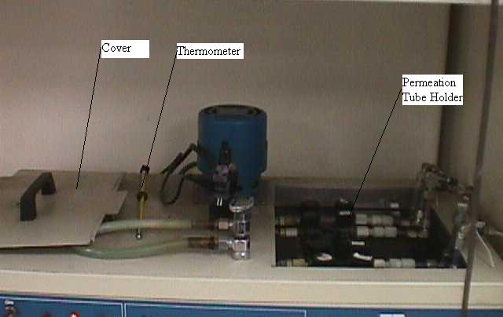
Figure 15. Detail illustration of water bath.

    - Remove cover from water bath.

    - Unscrew black cap from second (from back, first being the furthest back) permeation tube holder.

    - Using chrome tongs, carefully remove permeation tube from holder. Be careful not to drop permeation tube in the water bath. Water will render the permeation tube useless.

    - Place permeation tube in desiccant controlled environment chamber beside balance. The top of the environmental chamber is sealed with grease. Slide the top off to remove it.

    - Using the Teflon tongs, remove the 5 gram control weight standard from the environmental chamber.

    - Ensure the balance is set to read to 0.00001 gram. Zero the balance if necessary. Gently place control weight on center of balance.

    - On the Daily Balance Data Sheet, enter date and balance reading. Do not proceed if balance reading is greater than 0.00005 g from control weight’s certified value. Certification letter should be posted next to balance.

      - If greater than 0.00005 g from certified value, gently remove weight with Teflon tongs.

      - Tare the balance by pressing the TARE button.

      - Place control weight on center of balance. On Daily Balance Data Sheet, record date and balance reading. If reading greater than 0.00005 g from certified value. Stop and contact staff to have balance recalibrated.

    - Remove weight from balance and place in glass environmental chamber.

    - Using metal tongs, remove permeation tube and gently place in tube holder on balance.

    - On Permeation Tube Data Sheet, record date, time and balance reading in appropriate columns. Ensure permeation tube number corresponds to number on data sheet.

    - Remove permeation tube from balance and place in tube holder in water bath.
    - Screw black cap onto tube holder.

    - Ensure water level is up to fittings towards top of tube holder. Fill with deionized water if necessary.

    - Replace water bath cover.

    - Reinstall water bath thermometer in cover.

    - Using Teflon tongs, remove control weight from environmental chamber.

    - Place in center of balance. Record balance reading in “Post Balance Reading”. Ensure the reading is not greater than 0.00005 g from the weight’s certified value.

      - If greater than 0.00005 g, remove weight from balance and retare balance by pressing the TARE button.

      - Replace the weight. Record reading on Daily Balance Data Sheet. If greater than 0.00005 g from the certified value, stop and contact vendor to recalibrate balance.

      - Ensure Pre and Post readings are not greater than 0.00005 grams difference. If so, stop and consult staff. Line out readings taken in step 5.5.12.

    - On any PC in the Standards Lab, open Excel. At WINDOWS screen, press the Start button using the computer’s mouse. Select the Programs option. Select the Microsoft Excel option.

    - Using the computer’s mouse, select the File menu. Select the Open option. Access the K-drive. Open the Qpro subdirectory. Double click the “perm_tube_calc.xls” file.

    - Ensure the initial balance data for the permeation tube are entered in cells C7, D7, and E7 from the Permeation Tube Data Sheet.

    - Enter the previous weighing sessions data in C9, D9, and E9.

    - Enter today’s weighing data in C11, D11, and E11.

    - To account for daylight savings transitions, enter 1, 0, or –1 in cells D2 and D3. For Spring transitions, use a value of 1. For Fall transitions, use a value of –1. If no transitions, use a value of 0.

    - Enter data highlighted in yellow onto the Permeation Tube Data Sheet.

    - Average the last several (up to 5) values from the “Permeation Rate” column of the Permeation Tube Data Sheet. Enter this value in step 5.2.20 for SO₂ gas concentration.

    - Close spreadsheet by selecting File from the menu. Select the Close option and answer Yes to the question.

- SOURCE GAS CYLINDER CERTIFICATION PROCEDURE

  - ANALYZER CALIBRATION PROCEDURE

    - Perform gas cylinder setup, step 6.2

    - Perform selection of gas standard, step 6.3

    - At the Dos prompt, type “Release”. Then press the Enter key.

    - At the DOS prompt, type ”STDLAB_S”. Then press the Enter key. This will map the required network drives.

    - At the DOS prompt, type “GASS”. Then press the Enter key

    - At the Gas Menu, type “SR” (type “BR” if running the Source Gas Analysis System simultaneously). Then press the Enter key.

    - Enter the number of runs you wish to perform for each gas system. Then press the Enter key.

    - Enter “N” in the Continuous Run selection, then press the Enter key. If more than 1 was entered on previous step, entering “Y” will perform the runs one-after another. If more than 1 was entered on previous step, entering “N” will perform the runs on consecutive days starting at 16:00.

    - Enter “N” in the Print Results selection, then press the Enter key. Entering “Y” will print the results automatically (this is not recommended if performing more than one run per day).

    - Enter the time you wish to start the calibration run. Then press the Enter key.

    - If any of the gas standards or the MFC are out of certification, a warning screen will appear. The only warnings permissible to be discarded are “MFC certifications greater than 30 days”. All other warnings are to be heeded and the gas calibration procedure must be terminated.

    - Type “Q” and press the Enter key. This will bypass the purge program already performed in step 5.2.

    - Gas program is now running. Calibration will be completed in approximately 8 to 16 hours. When completed perform step 5.4.

  - GAS CYLINDER SETUP

    - Move guest cylinders in cylinder bays 1 through 12. Depending upon number of gas standards required from step 6.3, reserve appropriate number of bays for them.

WARNING! Securely fasten all cylinders using the safety chains or cylinder safety stands.

    - Remove all the cylinder caps and remove rubber band holding cylinder tags.

    - Using the appropriate type of regulator, attach regulators to all cylinders. Tighten regulator until securely fastened using large adjustable wrench. Use approximately 40 lbs. of force at end of wrench.

    - Open each cylinder valve slowly. Observe any audible sign of a leak. Immediately check for leaks using SNOOP LEAK DETECTOR.

      - If there is any sign of a leak, immediately the close cylinder valve. Vent the regulator using vent line located under Ambient Dilution Unit located on north wall.

      - If not able stop leak by applying additional torque (up to 50 lbs. at the end of the wrench) to regulator, remove regulator and try another regulator. Check for scores on Teflon seal. If any present, replace seal.

      - On metal to metal seal type regulators, cut a 2 inch strip of wide (1 inch) Teflon tape. Fold tape in half to form 1 inch square. Using scissors, cut a slit perpendicular into the fold. Unfold the Teflon tape. See Figure 13.

      - Use Teflon tape to form seal on the regulator fitting that meets cylinder. Torque regulator. Open cylinder and check for leaks. See Figure 14.

      - If leaks still present, use a different regulator.

    - Connect Teflon gas line to regulator. Gas line is labeled and corresponds to bay number.

    - Run PURGE program to condition regulators with gas.

      - Use the gas computer to run purge program. Log onto computer using User Name and Password provided by network manager.

      - Using the mouse, press START, then RUN. Type in “COMMAND”, then press OK.

      - At the DOS prompt, type “PURGE”, then press the Enter key.

      - At Purge entry screen, press the Enter key to accept normal purge time. Type “C” for conditioning purge, then press the Enter key. Type “S” for the Source GAS, then press the Enter key.

      - Wait approximately 30 seconds, type the cylinder bay number to purge. Press the Enter key after entering the bay number. Continue entering bay numbers until completed. Then type cylinder bay “99” to start the purge program. Press the Enter key.

      - At Purge entry screen, type “Q” to quit. Press the Enter key. All regulators and lines are purged with each respective cylinder’s gas.

    - Using the Source Gas Data Sheet, enter appropriate data for each cylinder in cylinder bay 1 through 11.
    - At the DOS prompt, type “GASS”, then press the Enter key.

    - At the GAS menu, type “SE” (for Source GAS Setup), then press the Enter key.

    - Enter data onto from ambient gas datasheet onto computer. When all data entered, press the Ctrl and End key simultaneously.

    - If certifying a secondary lab standard, then enter the number of gas corrections required. The source GAS runs single compound gases, therefore only one gas correction is allowed. Otherwise, enter “0”.

      - Type the concentration of the gas standard you would like “corrected to” in the first field, then enter the numerical gas type in the second field. Put an “R” in the bay for which you want the gas corrected (secondary gas standard) and an “S” in the bay that you want the guest cylinders corrected to (NIST SRM). If entered correctly, type “Y” and press the Enter key.

    - At the gas menu screen, type “O” and press the Enter key.

    - Go to the standards menu by typing “S” and press the Enter key.

    - Check the source MFC’s calibration data by typing “SM” and press the Enter key.

      - Verify the slope and intercept for each mass flow controller are entered correctly, edit if necessary. Ensure each MFC was certified within the last 45 days. Obtain the data from the most recent source MFC calibration folder. Press the Ctrl and End keys simultaneously.

    - Go to the standards menu by typing “S” and press the Enter key.

    - Check the instrument ranges for the Source GAS by typing “SA” and press the Enter key.

    - Verify that the instrument ranges for the gas type is entered. Use value determined from step 6.3.5 to determine desired analyzer range. Edit values if necessary. Press the Ctrl and End keys simultaneously.

    - Go to the standards menu by typing “S” and press the Enter key.

    - Check the source gas standards by typing “AG” and press the Enter key.

    - Verify that the proper cylinders numbers, location, gas type, concentration, and balance are entered properly. This gas will be used to calibrate the analyzer. Use gas determined in step 6.3.6. Edit values if necessary. Press the Ctrl and End keys simultaneously.

    - Press the Esc key twice. The Source GAS is now ready to start. Proceed to Gas Calibration Procedure, Step 6.1.

  - SELECTION OF LABORATORY STANDARD

    - Laboratory standard certifications are valid for one year. Ensure the selected laboratory standard is within the certification period prior to use. To recertify secondary gas standards, proceed to step 6.3.1.1. Otherwise, go to step 6.3.2.

      - Select a primary gas standard (NIST SRM) with a concentration within 5% of the laboratory standard’s concentration.

      - Place the NIST SRM in bay 1 through 11, the laboratory standard requires correction in step 6.2.10. Type the NIST SRM gas concentration in the first field, and place an “S” in the bay containing the NIST SRM. Type in an “R” in the bay containing the laboratory standards. Ensure the proper gas type is selected in the second field.

    - Determine the highest and lowest concentration guest cylinder to certify.

    - At the DOS prompt type “Q” and press the Enter key.

    - Press the / key, then the f key. Select “OPEN” from the display menu. Select the “cylinder” subdirectory, then select the “cylinder” subdirectory again. Select the file named “cyl_rang.wk1”.

    - At cell B21, enter analyzer ranges until the guest cylinder fits between the values in cells F32 and C25. Analyzer ranges can be obtained from the analyzer’s owners manual. Enter the selected analyzer range in step 6.2.18.

    - Select a NIST SRM with a concentration greater than cell F26, but less than C25. Enter the NIST SRM value in cell E21. Ensure all four calculated calibration dilution ratios are between 24 and 1200 (dilution ratios displayed in cells C15, D15, E15, and F15). Place the selected NIST SRM in any available cylinder bay between 1 and 11, then enter NIST SRM data in step 6.2.21.

    - To exit, press the / key, then the f key. Select “CLOSE”, and press the Enter key. Select “Yes”, and press the Enter key.

  - GAS CERTIFICATION PROCEDURE

    - If just completed step 6.1, go to step 6.4.2.

      - At the DOS prompt, type “Release”. Then press the Enter key.

      - At the DOS prompt, type ”STDLAB_S”. Then press the Enter key. This will map the required network drives.

      - At the DOS prompt, type “GASS”. Then press the Enter key

    - Type “O”, then press the Enter key.Type “P”, then press the Enter key. This will print the results of calibration run.

    - Press the Enter key twice. All historical calibration runs will be listed. Continue pressing the Enter key until the previous calibration run is displayed. Once displayed, note the exact title and extension. The previous calibration run can be determined by the title. For example H991112.11 was the first calibration run (determined by the “.11” file extension, the second run on this day will have a “.21” extension) performed on the Source Gas Calibration System (determined by the initial “H” prefix, the Ambient Gas System will by denoted by an “L”) on November 12, 1999 (“99” denotes the year, “11” denotes the month, and”12” denotes the day).

    - Enter the exact title and extension from step 6.4.3. Press the Enter key.

    - Press the Alt key and F key simultaneously. Then press the X key. Press the Alt key and F key simultaneously again. Then press the X key. The printer on the Metra computer will now begin to print the calibration report.

    - Determine if calibration run was valid. If determined to be invalid. Troubleshoot cause and perform step 6.1 again. Proceed only if calibration is valid using the following criteria.

      - Ensure that the correlation coefficient for the gas assayed is greater than 0.9999.

      - Ensure that the “delta AADCO”, and “delta Span” for the gas assayed is less than 0.800.

      - Review each voltage reading, ensure they are not denoted by an asterisk. An asterisk denotes that the gas did not stabilize (the standard deviation of nine consecutive minute averages is greater than 1.0 percent). Review the strip chart recorder to determine if gas stabilized (shown as a horizontal line). A trace that did not stabilize may require additional purges of the cylinder to condition its regulator and sample lines. Perform step 6.2.6. A noisy trace (data scattering around the recorded value) or one that will not stabilize after repeated conditioning purges may be the result of a contaminated regulator or operating the MFCs close to their minimum flow rate. Replace the regulator or change the analyzer range to allow the MFCs to operate at higher in their operating range.

    - Press the Esc key twice.

    - Press the C key, then press the Enter key.

    - Enter the cylinder number for the first cylinder to be certified. Then press the Enter key.

    - Using the arrow key, scroll down to the previous calibration runs date. Then scroll over to the gas to be certified. Enter a “YC” over the “Y” then press the Enter key. The gas program will use this value to determine certified concentration. Scroll up and change the earliest valid calibration results from a “YC” to a “YP”. If the cylinder has less than three valid calibrations, press the Esc key and rerun calibration procedure using step 6.1. Repeat step 6.4.9 using the next cylinder in the calibration report.

    - Press the Ctrl and End keys simultaneously.

    - Determine if the cylinder meets repeatability criteria of less than 1.00 Standard deviation. Mark each compound meeting the criteria with a “Y”. Enter a “Y” at bottom of screen to certify cylinder, then press the Enter key.

      - If any compound does not meet criteria, Press the Esc key and rerun calibration. Repeat step 6.4.9 for the next cylinder in the calibration report.

    - Enter a “Y” and press the Enter key. This will print out a cylinder tag.

    - Repeat step 6.4.9 using the next cylinder in the report. When completed, press the Esc key three times.

    - At the DOS prompt, type “Purge” and press the Enter key.

    - Press the Enter key. Type “N” and press the Enter key. This will perform a nitrogen purge of regulators and gas lines.

    - Type “S” to purge Source GAS (type “A” for the Ambient GAS). Press the Enter key.

    - On the printer that printed the cylinder tags. Press the ONLINE button, then the FORM FEED button. Remove the cylinder tags. Press the EMPTY button, then press the ONLINE button. Date each cylinder tag with the date of the calibration. Separate each tag. The original copy is to be filed, the carbon copy is placed in the cylinder tag holder around neck of cylinder. Ensure the correct cylinder tag is assigned to the correct cylinder.

    - Close all certified cylinder using valve on top of cylinder. Note the bay number they are in.

    - Enter the cylinder numbers from step 6.4.19. Press the Enter key after each entry. After last cylinder bay entered, type “99” and press the Enter key. The Purge program will run for approximately 10 minutes (depending upon the number of cylinders to purge).

    - Disconnect the gas lines from the certified cylinder’s regulator. Repeat for each certified cylinder. Using the vent line under the Ambient Dilution Unit on the North wall, vent each regulator of pressure. Remove regulators. Fasten the cylinder tag to cylinder using a rubber band. Screw on safety cap. Place sticker on top of cylinder cap denoting month certified and owner. Place cylinder in appropriate outgoing bay in cylinder room.

    - Enter “Q”, then press the Enter key.

    - Enter “GASS”, then press the Enter key.

    - Enter “SE” (“AE” for the Ambient GAS), then press the Enter key.

    - Remove the certified cylinder data from entry screen. Press the Ctrl and End keys simultaneously. Remove any correction entries for the certified cylinder. Enter a “Y” at the bottom of the screen and press the Enter key.

    - Press the Esc key to exit the Gas Analysis System.

- MASS FLOW CONTROLLER CERTIFICATION PROCEDURE

  - AMBIENT 200 CCM MASS FLOW CONTROLLER (MFC #1) SETUP

    - Set up of NO/NO_{x} analyzer to prevent contamination while calibrating MFC #1.

      - Flip up MFC switches #3 and #4 on the white ambient MFC panel (on gas instrument rack). Dial the thumbwheels to 700 for MFCs #3 and #4. This manually sets MFC #3 to run AADCO (house air) air through the NO/NO_{x} analyzer to protect it. See figure 6.

      - On the blue ambient control panel, flip solenoid switches 19, 12, 13, and 14 to the on (up) position. See Figure 7.

    - Set Up MFC #1 For Calibration.

      - Turn off (down) air supply toggle valve on right side of ambient dilution box (North Wall).

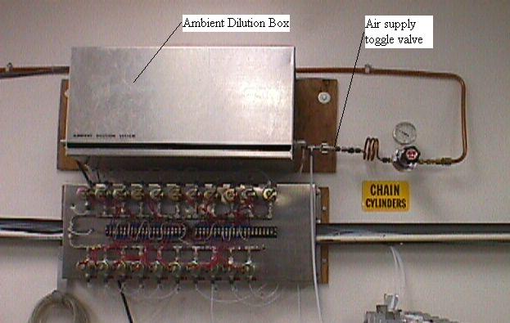
Figure 16. Picture of Ambient Dilution Box.

      - Connect Teflon cylinder line #20 of ambient gas cylinder rack to the Source GAS house air supply line on the left side of source dilution box (North Wall).

      - On the blue ambient control panel (on gas instrument rack), flip switches 20, 9, and toggle switch labeled "Brooks" to the on (up) position.

      - On the white ambient MFC panel, flip up MFC switch #2. Dial the thumbwheel to 000 for MFC #2. This will prevent interference from MFC #2.

      - Turn MFC display knob on white ambient MFC panel to #1. This will display the percentage value of the flow rate to the selected MFC.

      - The air from MFC #1 is now routed to the gray output post in the flow standard work area. The output is labeled "MFC Calibration".

Figure 17. Picture of gray output post in flow room.
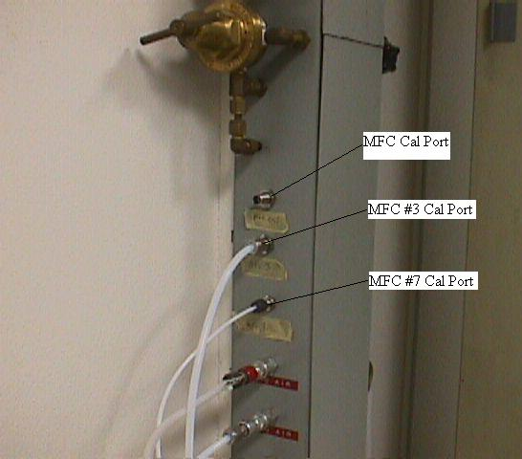
      - Connect a Teflon line from the output to the flow standard (Sierra or Brooks).

      - MFC #1 is ready to calibrate. (Go to Step 7.7 for calibration procedure)

    - Returning to Original Setup Procedure

7.1.3.1 Disconnect flow standard from output port on gray post.

      - On the white ambient MFC panel, flip down MFC switch #2.

      - On the blue ambient control panel (on gas instrument rack), flip switches 20, 9, and toggle switch labeled "Brooks" to the off (down) position.

      - Disconnect Teflon cylinder line #20 from the Source GAS house air supply line.

      - Turn on (up) air supply toggle valve on right side of ambient dilution box.

      - On the blue ambient control panel, flip solenoid switches 19, 12, 13, and 14 to the off (down) position.

      - Flip down MFC switches #3 and #4 on the white ambient MFC panel (on gas instrument rack).

      - At the DOS prompt, type “RSET”. Press the Enter key. The Ambient GAS is in standby state.
  - AMBIENT 30 LPM MASS FLOW CONTROLLER (MFC #2) SETUP

    - Set up of NO/NO_{x} analyzer to prevent contamination while calibrating MFC #2.

      - Flip up MFC switches #3 and #4 on the white ambient MFC panel (on gas instrument rack). Dial the thumbwheels to 700 for MFCs #3 and #4. This manually sets MFC #3 to run AADCO (house air) air through the NO/NO_{x} analyzer to protect it. See Figure 6.

      - On the blue ambient control panel, flip solenoid switches 19, 12, 13, and 14 to the on (up) position. See Figure 7.

    - Set Up MFC #2 for calibration.

      - On blue ambient control panel (on gas instrument rack), flip toggle switch labeled "Brooks" to the on (up) position.

      - On white ambient MFC panel, flip up MFC switch #1 and set thumbwheel to 000. This prevents interference from MFC #1.

      - Turn MFC display knob on white ambient MFC panel to #2. This will display the percentage value of the flow rate to the selected MFC.

      - The air from MFC #2 is now routed to the gray output post in the flow standard work area. The output is labeled "MFC Calibration". See Figure 17.

      - Connect a Teflon line from the output to the flow standard (Sierra or Brooks).

      - Make sure the two-way valve on the source dilution box (North Wall) is in the "To Dil. Gas Out Source Manifold" position. This will insure no interference from MFC #5 of the source dilution system.

Figure 18. Side view of Source Dilution Box.
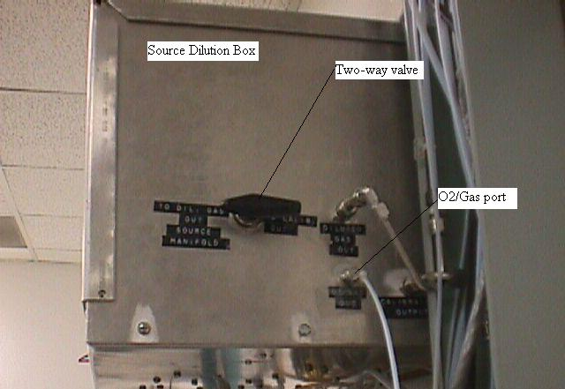
      - MFC #2 is now ready for calibration. Use MLD Method #5721 in conjunction with step 7.7 to calibrate MFC#2.

    - Returning to Original Setup Procedure

7.2.3.1 Disconnect flow standard from output port on gray post.

      - On the white ambient MFC panel, flip down MFC switch #1.

      - On the blue ambient control panel (on gas instrument rack), flip the switch labeled "Brooks" to the off (down) position.

      - On the blue ambient control panel, flip solenoid switches 19, 12, 13, and 14 to the off (down) position.

      - Flip down MFC switches #3 and #4 on the white ambient MFC panel (on gas instrument rack).

      - At the DOS prompt, type “RSET”. Press the Enter key. The Ambient GAS is in standby state.

  - AMBIENT 10 LPM MASS FLOW CONTROLLER (MFC #3) SETUP

    - Calibration of MFC #3 will not contaminate the NO/NO_{x} analyzer. No special alignment for this reason required.

    - Set up MFC #3 for calibration.
      - On blue ambient control panel (on gas instrument rack), flip toggle switch 19 to the on (up) position.

      - On white ambient MFC panel, ensure all four MFC switches to the down position. See Figure 6.

      - Turn MFC display knob on white ambient MFC panel to #3. This will display the percentage value of the flow rate to the selected MFC.

      - Turn the valve to the down position (labeled from MFC 3) located on the gray output post on the left side of the blue vacuum hood (South Wall).

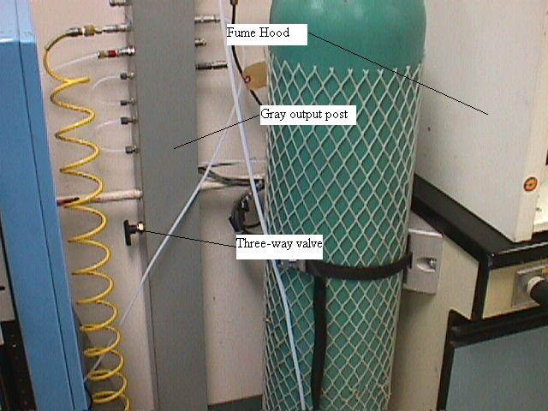
Figure 19. Picture of gray output post next to fume hood.

      - The air from MFC #3 is now routed to the gray output post located in the flow standard work area. The output is labeled "From MFC #3". See Figure 17.

      - Connect a Teflon line from the output to the flow standard (Sierra or Brooks).

      - MFC #3 is now ready for calibration. Use MLD Method #5721 in conjunction with step 7.7 to calibrate MFC#3.

    - Returning to Original Setup Procedure

7.3.3.1 Disconnect Teflon line from port labeled “From MFC #3” on gray output post in flow standard work area.

      - Turn the valve to the up position (labeled from MFC 3) located on the grey output post on the left side of the blue vacuum hood (South Wall).

      - On blue ambient control panel (on gas instrument rack), flip toggle switch 19 to the off (down) position.

      - At the DOS prompt, type “RSET”. Press the Enter key. The Ambient GAS is in standby state.

  - SOURCE 30 LPM MASS FLOW CONTROLLER (MFC #5) SETUP

7.4.1 Set up MFC #5 for calibration.

      - On white source control MFC panel (on gas instrument rack), dial thumbwheel for MFC #6 to 000 and flip toggle switch to the up position. This will prevent any interference from MFC #6. See Figure 10.

      - On the silver Source Dilution box (North Wall), turn the two-way valve to the "Calib. Out" position. See Figure 18.

      - Turn MFC display knob on white source MFC panel (on gas instrument rack) to position #5. This will display the percentage value of the flow rate to the selected MFC.

      - The air from MFC #5 is now routed to the gray output post in the flow standard work area. The output is labeled "MFC Calibration". See Figure 17.

      - Connect a Teflon line from the output to the flow standard (Sierra or Brooks).

      - MFC #5 is now ready for calibration. Use MLD Method #5721 in conjunction with step 7.7 to calibrate MFC #5.

    - Returning to Original Setup Procedure

      - Disconnect Teflon line from the port labeled “MFC Calibration” on the gray output post in the flow standard work area.

      - On the silver Source Dilution box (North Wall), turn the two-way valve to the " To Dil. Gas Out Source Manifold " position.

      - On white source control MFC panel (on gas instrument rack), flip toggle switch for MFC #6 to the down position.

      - At the DOS prompt, type “RSET”. Press the Enter key. The Source GAS is in standby state.

  - SOURCE 200 CCM MASS FLOW CONTROLLER (MFC #6) SETUP

7.5.1 Set up MFC #6 for calibration.

      - Turn off (down) air supply toggle valve on the left side of source dilution box (North Wall).

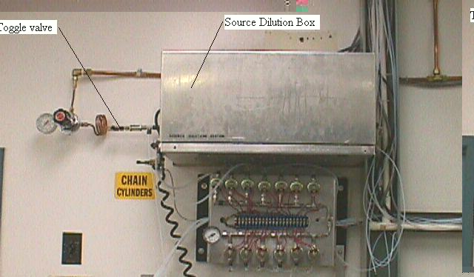
Figure 20. Picture of Source Dilution Box.

      - On the white source MFC panel (on gas instrument rack), flip the toggle switches for MFC #5 and #7 up and set thumbwheels to 000. This prevents interference from MFCs #5 and #7. Turn MFC display knob to #6. This will display the percentage value of the flow rate to the selected MFC. See Figure 10.

      - Connect the Teflon line labeled House Ambient Air from the ambient dilution box (North Wall) to any gas cylinder line (Source Gas Rack) #2 - #12. Then on the gray source control panel (on gas instrument rack), flip the respective solenoid toggle switch to the up position. See Figure 11.

      - Turn the two-way valve (arrow points direction) on the Source Dilution box (North Wall) to the "To Calib. Out" position. See Figure 18.

      - The air from MFC #6 is now routed to the gray output post located in the flow standard work area. The output is labeled "MFC Calibration". See Figure 17.

      - Connect a teflon line from the output to the flow standard (Sierra or Brooks).

      - MFC #6 is now ready for calibration. Use MLD Method #5721 in conjunction with step 7.7 to calibrate MFC#6.

    - Returning to Original Setup Procedure

      - Disconnect Teflon line from the port labeled “MFC Calibration” on the gray output post in the flow standard work area.

      - On the silver Source Dilution box (North Wall), turn the two-way valve to the " To Dil. Gas Out Source Manifold " position.

      - Disconnect the Teflon line labeled House Ambient Air from the ambient dilution box (North Wall) from the gas cylinder line used in step 7.5.1.3. Then on the gray source control panel (on gas instrument rack), flip the respective solenoid toggle switch to the down position.

      - On the white source MFC panel (on gas instrument rack), flip the toggle switches for MFC #5 and #7 down.

      - Turn on (up) air supply toggle valve on the left side of source dilution box (North Wall).

      - At the DOS prompt, type “RSET”. Press the Enter key. The Source GAS is in standby state.

  - SOURCE 50 CCM MASS FLOW CONTROLLER (MFC #7) SETUP

    - Set up MFC #7 for calibration.

      - On white source MFC control panel (on gas instrument rack), set MFC #5 and #6 thumbwheels to 000 and flip the toggle switch to the up position. This will prevent any interference from MFC #5 and #6. See Figure 10.

      - Turn off the source air supply by flipping down the toggle valve located on the left side of the silver Source Dilution box (North Wall). See Figure 20.
      - Remove the Teflon line labeled "O2" from the O2/Gas port located of the right side of the silver Source Dilution box (North Wall). Connect the Teflon line labeled "Gas to Brooks" (located next to O2 line), to the O2/Gas port. See Figure 18.

      - On the gray Source control panel (gas instrument rack), turn on solenoid valve switch #15 (up position) and the switch labeled "O2 Analyzer". See Figure 11.

      - Turn MFC display knob on white source MFC panel (on gas instrument rack) to #7. This will display the percentage value of the flow rate to the selected MFC.

      - The air from MFC #7 is now routed to the gray output post in the flow standard work area. The output is labeled "From MFC 7".

      - Connect a Teflon line from the output (port labeled “From MFC 7”) to the flow standard (Sierra or Brooks). See Figure 17.

      - MFC #7 is now ready for calibration. Use MLD Method #5721 in conjunction with step 7.7 to calibrate MFC #7.

    - Returning to Original Setup Procedure

      - Disconnect Teflon line from the output (port labeled “From MFC 7”) to the flow standard (Sierra or Brooks).

      - On the gray Source control panel (gas instrument rack), turn off (down) solenoid valve switch #15 and the switch labeled "O2 Analyzer".

      - Remove the Teflon line labeled "Gas to Brooks" from the O2/Gas port located of the right side of the silver Source Dilution box (North Wall). Connect the Teflon line labeled "O2", to the O2/Gas port.

      - Turn on the source air supply by flipping up the toggle valve located on the left side of the silver Source Dilution box (North Wall).

      - On white source MFC control panel (on gas instrument rack), flip the toggle switches for MFC #5 and #6 to the down position.

      - At the DOS prompt, type “RSET”. Press the Enter key. The Source GAS is in standby state.

  - MASS FLOW CONTROLLER CALIBRATION PROCEDURE

      - Use MLD Method #5721 in conjunction with the following steps to perform the MFC calibrations. The following steps will allow control of the MFCs, operation of the primary flow standards (Brooks and Sierra) are outlined in MLD Method #5721.

    - Leak check the MFC under test.

      - Using the gas computer, type “MFCCAL” at the DOS prompt. Press the Enter key.

      - The computer screen will display the following:
MFC CALIBRATION
Enter MFC #[1 - 7]:

      - Type the number corresponding to the MFC under test. Press the Enter key.

      - The computer screen will display the following:
Enter Output Voltage [0 - 5]:

      - Type “0” (zero), then press the Enter key. This set the MFC under test to allow 0% flow.

      - The computer screen will display the following:
Enter Number of Scan [0 to END]

      - Type in the number of scans desired. This will sample the voltage output from the MFC under test. Typically, 30 scans will provide an adequate number of scans. Press the Enter key.

      - The computer screen will display the following:
END of scan #1==> Avg. = (value) Standard Dev. = (value)
END of scan #2==> Avg. = (value) Standard Dev. = (value)
END of scan #3==> Avg. = (value) Standard Dev. = (value)
END of scan #4==> Avg. = (value) Standard Dev. = (value)
END of scan #5==> Avg. = (value) Standard Dev. = (value)
Etc... to the end scan selected.

TOTAL AVERAGE READING= (value) STANDARD DEVIATION= (value)
CONTINUE CALIBRATION WITH OLD PARAMETERS? <Y/N>

      - Type “Y” for yes or “N” for no. Typing “Y” will initiate step 7.7.2.1.8. Typing “N” will initiate step 7.7.2.1.2. Press the Enter key.

        - If “Y” was pressed, the computer screen will display the following:
-enter Number of Scan: [(value) Return to accept this value]

        - Type in new number of scans desired and press the Enter key, or simply press Enter to continue with the previous setting.

        - Record the voltage display (for zero flow) from the gas computer after the scanning procedure. Record the value (on flow calibration data sheet) when the standard deviation is at a minimum for the flow percentage point. This is your initial zero flow (in volts) display.

        - Type “N” to stop that scanning procedure. The computer screen will display the following:
CONTINUE MFC CALIBRATION? <Y/N>

        - Type “Y” and press the Enter key.

      - The computer screen will display the following:
MFC CALIBRATION
Enter MFC #[1 - 7]:

      - Type the MFC number under test. Press the Enter key.

      - The computer screen will display the following:
Enter Output Voltage [0 - 5]:

      - Type “5.0”, and press the Enter key. This will allow full flow through the MFC under test.

      - The computer screen will display the following:
Enter Number of Scan [0 to END]

      - Type in the desired number of scans. Typically, 30 scans should be adequate. Press the Enter key.

      - The computer screen will display the following:
END of scan #1==> Avg. = (value) Standard Dev. = (value)
END of scan #2==> Avg. = (value) Standard Dev. = (value)
END of scan #3==> Avg. = (value) Standard Dev. = (value)
END of scan #4==> Avg. = (value) Standard Dev. = (value)
END of scan #5==> Avg. = (value) Standard Dev. = (value)
Etc... to the end scan selected.

TOTAL AVERAGE READING= (value) STANDARD DEVIATION= (value)
CONTINUE CALIBRATION WITH OLD PARAMETERS? <Y/N>

      - Press “Y”, and the Enter key twice to reinitiate sampling the MFC voltage.

      - If using the Sierra flow calibrator, go to the leak test mode by pressing the Esc key until the main menu is displayed. Either press the down arrow key until in the leak test position or press the letter L.

        - Select the tube that best matches the maximum flow that is to be run (tube flow ranges are display at the base of flow standard). Either press the down arrow key until the desired tube is in position or press the B key to test the big tube, press the M key to test the medium tube, and press the S key to test the small tube.

        - Press the Enter key and the test will begin. As the piston rises watch the Cal-Bench box to the right of the computer and when the display reads 1.8 (or piston is half way up the tube) turn the valve on the left side of the Cal-Bench to the off position (valve arrow pointing perpendicular to air flow through the valve).

        - Wait approximately five minutes and press the A key to start the actual leak test procedure. This will take approximately three minutes. The Sierra computer display will indicate whether the test failed or passed.

      - If using the Brooks flow calibrator, select the tube that best matches the maximum flow rate for the MFC under test. Use the selector switch to select the desired tube.

        - Press the Reset button, then press the Start button. Once the piston has risen approximately halfway up the tube, turn the valve on the left side of the Cal-Bench to the off position (valve arrow pointing perpendicular to air flow through the valve).

        - Using a piece of tape, mark the level of the piston on the glass cylinder at the mercury seal. Wait 5 minutes. If a gap develops between the tape and the mercury seal, then a leak exists in the Brooks flow standard. Troubleshoot leak between the valve on step 7.7.2.19.1 and the Brooks flow standard.

      - Watch the standard deviation and the voltage value on the gas computer screen for the MFC being tested. Record the voltage value (as final zero flow) once the display has stabilized (minimum standard deviation). Compare this recorded voltage value with the initial voltage value (zero flow) previously recorded. If comparison meets leak check criteria of MLD Method #5721, then proceed with calibration. If not, determine cause of leak and perform leak check procedure. This test is checking for leaks in the system under pressure.

      - Slowly turn the valve on the left side of the Cal-Bench to the on position (arrow inline with flow through the valve).

        - If using the Sierra flow calibrator, press the Esc key to get to the main menu and then press the up arrow keys until calibrate in position and press Enter key, or press C and the Enter key to reach the calibrate mode.

7.7.2.22 The computer screen will display the following:
END of scan #1==> Avg. = (value) Standard Dev. = (value)
END of scan #2==> Avg. = (value) Standard Dev. = (value)
END of scan #3==> Avg. = (value) Standard Dev. = (value)
END of scan #4==> Avg. = (value) Standard Dev. = (value)
END of scan #5==> Avg. = (value) Standard Dev. = (value)
Etc... to the end scan selected.

TOTAL AVERAGE READING= (value) STANDARD DEVIATION= (value)
CONTINUE CALIBRATION WITH OLD PARAMETERS? <Y/N>

    - Calibration Procedure

      - Type “Y” and press the Enter key.

      - The computer screen will display the following:
Re-enter Number of Scan: [(value) Return to accept this value]

      - Type in the number of scans desired and press the Enter key, or press Enter only to continue with the old parameter. Keep repeating steps 7.7.3 through 7.7.5 until the MFC voltage has been sampled four times. Record the average voltage reading for the 100 % flow point on the flow data sheet.

      - Using one of the primary flow calibrators, determine the standard flow at this setpoint.

      - Type “N” and press the Enter key. The computer screen will display the following:
CONTINUE MFC CALIBRATION? <Y/N>

7.7.3.6 Type “Y” and press the Enter key. The computer screen will display the following:
MFC CALIBRATION
Enter MFC # [1 - 7]

7.7.3.7 Type the number of the MFC under test. Then press the Enter key.

7.7.3.8 The computer screen will display the following:
Enter Output Voltage [0 - 5]:

      - Type “3.75” and press the Enter key. This will target the next flow setting.

      - The computer screen will display the following:
Enter Number of Scan [0 to END]

      - Type in the number of scans desired and press the Enter key.

      - The computer screen will display the following:
END of scan #1==> Avg. = (value) Standard Dev. = (value)
END of scan #2==> Avg. = (value) Standard Dev. = (value)
END of scan #3==> Avg. = (value) Standard Dev. = (value)
END of scan #4==> Avg. = (value) Standard Dev. = (value)
END of scan #5==> Avg. = (value) Standard Dev. = (value)
Etc... to the end scan selected.

TOTAL AVERAGE READING= (value) STANDARD DEVIATION= (value)
CONTINUE CALIBRATION WITH OLD PARAMETERS? <Y/N>

      - Type “Y” and press the Enter key.

      - The computer screen will display the following:
Re-enter Number of Scan: [(value) Return to accept this value]

      - Type in the number of scans desired and press the Enter key, or press Enter only to continue with the old parameter. Keep repeating steps 7.7.15 through 7.7.17 until the MFC voltage has been sampled four times. Record the average voltage reading for the flow point on the flow data sheet.

      - Using one of the primary flow calibrators, determine the standard flow at this setpoint.

      - Type “N” and press the Enter key. The computer screen will display the following:
CONTINUE MFC CALIBRATION? <Y/N>

      - Type “Y” and press the Enter key.

      - Repeat steps 7.7.8 through 7.7.19 for each of the following settings. For step 7.7.11, substitute the setting value for 3.75.
Setting Value Targeted flow rate
2.5 = 50 % of full scale flow
1.25 = 25 % of full scale flow
0.625 = 12.5 % of full scale flow

      - When completed, type “N” and press the Enter key following step 7.7.19. This will exit the MFCCAL program.

      - Go back to MFC setup procedure for MFC under test and return system to original settings using the step 7.X.3 for the Ambient GAS, step 7.X.2 for the Source GAS.

- BACKUP ZERO AIR SUPPLY IMPLEMENTATION PROCEDURE

  - PLACING BACKUP ZERO AIR SUPPLY IN SERVICE.

    - On each AADCO zero air generator units, press the red POWER and PUMP switches. This will energize both units. Allow AADCO units to warm up for 1 hour. Ensure AADCO outputs are connected to grey post via quick disconnects.

    - Bleed off any water from the water traps by press the Ballast Bleed button. Depress button for approximately 10 seconds.

    - Close house air cutout valve located above ceiling tiles above wall clock located on east wall of Standards Laboratory.

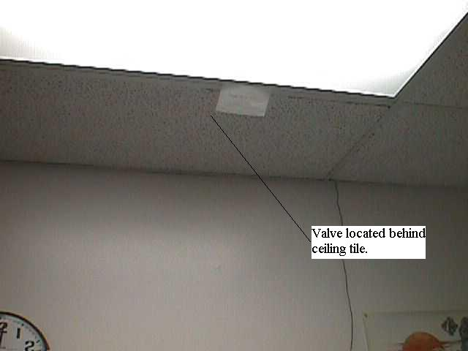
Figure 21. Picture showing location of house air cutout valve.
    - On back of instrument rack, turn two-way valve to down position.

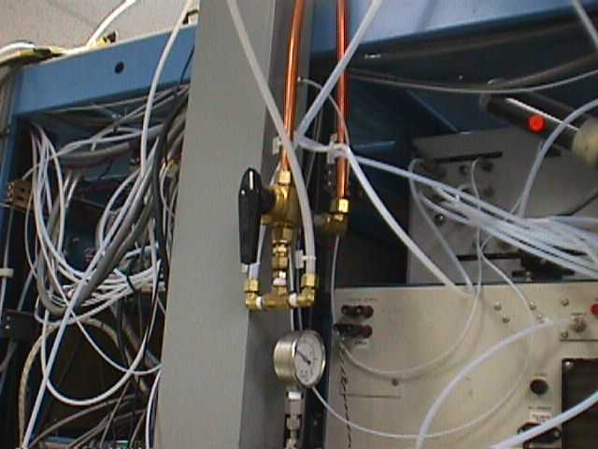
Figure 22. Picture showing location of instrument rack two-way valve.

  - REMOVING BACKUP ZERO AIR SUPPLY FROM SERVICE.

    - On back of instrument rack, turn two-way valve to down position. See Figure 22.

    - Open house air cutout valve located above ceiling tiles above wall clock located on east wall of Standards Laboratory. See Figure 21.

    - Deenergize both AADCO zero air units by pressing the POWER and PUMP switches.

- QUALITY CONTROL PRACTICES

  - DAILY PRACTICES

    - After each calibration, review all data points taken. Step 5.4.6.3 allows user to review data for high variability data (denoted by asterisk). User may validate the datapoint by referring to the chart recorder and reviewing the trace for the questioned datapoint. If trace is variable around the datapoint taken, then user may validate the datapoint. If not, then mark datapoint as bad. Generally, datapoints marked by an asterisk during an analyzer calibration should not be validated as it can affect all guest cylinder assayed for that gas.

    - After each calibration, review the calibrations for each analyzer. Step 5.4.6.1 and 5.4.6.2 details criteria for a valid calibration of each analyzer. The analyzer must be linear across its intended range (greater than 0.9999 correlation) and stabile during its use ( pre-zero and post-zero, and pre-span and post-span cannot be greater than 0.08 volts different).

    - After valid three assays of a cylinder, the standard deviation of the assayed value cannot be greater than 1%. This ensures that the gas concentration is stable within the cylinder. Step 5.4.12 details the procedure for verifying this.

    - The control gas standard is evaluated daily to aid in determining the validity of the calibration period. Plot each compound’s assayed value on the control charts.

      - For warning level violations, the analyzer calibration results are reviewed again to determine possible causes. If no cause can be found, data may still be considered valid if the calibration requirements of steps 9.1.2 and 9.1.3 are met.

      - For action level violation, all data for the compound exceeding the action limits are considered compromised. All compromised data must be invalidated and noted. Commence analyzer and calibration system troubleshooting. If no cause can be found, assay the control standard only. If values return to normal, treat the condition as an anomaly. If values continue to violate the action limits, recertify all laboratory standards, then reassay the control standard.

    - After each calibration, the calibration results are stored in their appropriate GAS binder (source or ambient). The original cylinder tag copy is stored in a storage cabinet, sorted by guest agency.

    - After each calibration, review the displays on each analyzer for fault codes. Data should not be considered valid for an analyzer displaying a fault code, no matter how insignificant the fault code.

  - BIWEEKLY PRACTICES

    - Determine the permeation rate for the SO₂ permeation tubes on a biweekly basis. This will ensure the permeation rate is constant for the period of its use. Step 5.4 outlines the procedure to determine the permeation rate.
  - MONTHLY PRACTICES

    - MFC certifications are valid for 45 days. The GAS program will alert user after 30 days have elapsed since last certification. Do not assay gas after the 45 day period has elapsed. All assays performed after the 45 day certification period must be consider invalid. Step 7 outlines the procedure for the certification of all the MFCs.

  - QUARTERLY PRACTICES

    - Recalculate the control charts for the control gas on a quarterly basis. Use the results from the previous quarter to determine the warning and action limits for the next quarter.

    - Clean the cooling fan inlet filters on all analyzer quarterly. Dirty fan screens may cause the slight heating of the sample gas, inadvertently biasing the assayed values.

  - ANNUAL PRACTICES

    - Determination of Efficiency of Thermal Oxidizer.

      - Energize Houston Atlas H₂S analyzer, allow to warm up for 1 hour minimum.

      - Connect the output of the sample pump to the input of the H₂S analyzer.

      - Connect the Teflon line labeled “H₂S” to the inlet of the sample pump.

      - Energize the sample pump.

      - On the back of the thermal oxidizer, connect the line labeled “H Atlas H₂S” to the inlet tee connector.
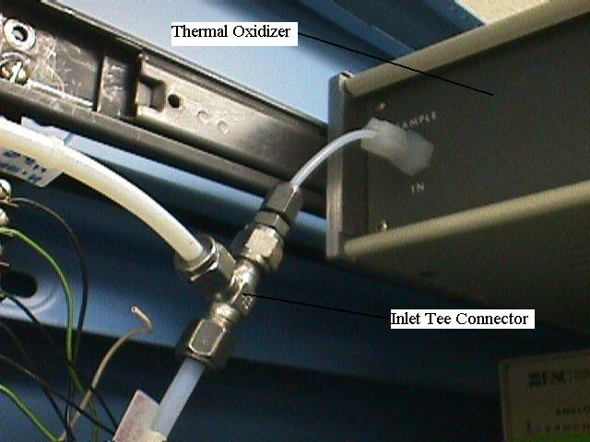
Figure 23. Picture of inlet tee to thermal oxidizer.

      - Connect a H₂S laboratory standard to any cylinder bay 20 through 31, per step 5.2.

      - At the “GAS” computer, press the Start button, select the Run option. At the input line, type “COMMAND” and press the Enter key.

      - At the DOS prompt, type “AUTO” and press the Enter key.

      - Initiate the Ambient GAS by typing “A” and pressing the Enter key.

      - Type “4” (the channel corresponding to the H₂S analyzer) and press the Enter key twice.

      - Type “0.1” (sample interval) and press the Enter key.

      - Type “500” (number of samples) and press the Enter key.

      - Type “DIL” (enters the dilution settings) and press the Enter key.

      - Type “0.500” (range of H₂S analyzer) and press the Enter key. Enter the concentration of the H₂S laboratory standard, then press the Enter key. Type “90” (targeted percent of range) and press the Enter key. Type “Y” and press the Enter key. Type “Y” and press the Enter key.

      - Type “SIL” (enters the solenoid settings) and press the Enter key.

      - Type “A” (activates the ambient GAS solenoids) and press the Enter key. Type the cylinder bay location of the H₂S laboratory standard, then press the Enter key. Press the Esc key to exit the solenoid screen.

      - Press the Enter key to start acquiring data. Allow at least ten minutes for analyzers to stabilize.

      - Record front panel display of H₂S analyzer. Record the “TS” (TS corresponds to H₂S) reading on the computer.

      - Disconnect the line labeled “H Atlas H₂S” from the back of the input tee to the thermal oxidizer. Cap the open input tee connection.

      - Uncap output tee connection on the back of the thermal oxidizer. Connect the Teflon line labeled “H Atlas H₂S” to the output tee of the thermal oxidizer. Allow 10 minutes for the analyzer to stabilize. It should stabilize at zero.

      - Using a grease pencil, mark the needle position on the front panel of the H₂S analyzer. Record value.

      - On the computer, press the Ctrl and End keys simultaneously. At the DOS prompt, type “RSET” and press the Enter key. Allow 10 minutes for analyzer to stabilize.

      - Record the value on the front panel of the H₂S analyzer. Compare value to value from step 9.5.1.21.

      - Using following equation, determine thermal efficiency. Thermal efficiency should be greater than 99.9%. Troubleshoot and repair the thermal oxidizer if criteria not met.
      - Shut cylinder valve on top of H₂S laboratory standard.

      - At DOS prompt, type “PURGE” and press the Enter key.

      - At entry screen, press the Enter key. Type “N” (for nitrogen purge) and press the Enter key. Type “A” (for ambient GAS) and press the Enter key. Allow time for MFC alignment for purge program. Type the cylinder bay number containing the H₂S laboratory standard. Press the Enter key. Type “99” and press the Enter key. The system is now purging with nitrogen.

      - When purge program complete, disconnect quick-connect Teflon line from regulator on H₂S cylinder. Remove the regulator. Replace cylinder cap. Remove H₂S laboratory standard from cylinder bay and store.

      - On the computer, type “Q” and press the Enter key. The gas system has been restored to idle condition.

  - BIENNIAL PRACTICES

    - Determination of Analytical Accuracy.
      - 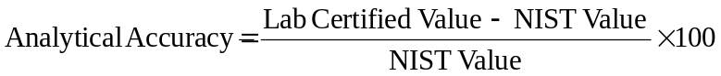Analytical accuracy should be determined on a biennial basis. Analytical accuracy is our ability to accurately assay a gas. To determine our analytical accuracy, use a NIST SRM gas and treat it as if it were a guest cylinder. Assay the NIST SRM against a laboratory gas standard, at least three times. Certify it as if it were a guest cylinder. The analytical accuracy for that specific gas is the laboratory determined certified value compared to the NIST certified value. The formula is as follows:

      - Gas compounds must be assayed as independent compounds. It is not possible to assay the analytical accuracy of blended compounds, NIST does not provide blended SRMs.

    - Determination of Gas Concentration Correction Factors.

      - Obtain at least five different concentrations of a gas to test. The concentrations should span the entire concentration range you intend to use.

      - Place the cylinders in the source bays starting. Arrange them from lowest to highest, the lowest going in bay 1. This is done to prevent confusion, arranging them in any order will achieve the same result.

      - Perform step 6.2

      - Perform step 7.5.1, Set up MFC #6 for calibration. On step 7.5.1.3, connect the Teflon line labeled House Ambient Air from the ambient dilution box (North Wall) to any gas cylinder line (Source Gas Rack #2 through #12) that does not have a gas cylinder in it. Note this bay as your zero air bay. On step 7.5.1.6, connect the output port to the Brooks flow standard.

      - Perform step 7.7.2, Leak check the MFC under test.

      - Perform step 7.7.3.1 through 7.7.3.1.4 using the zero air bay (from step 8.5.1.4) as your source of gas. This will determine you 100% flow rate through the MFC using zero air.

      - On the gray source control panel (on gas instrument rack), flip the solenoid toggle switch for the cylinder bay containing the lowest concentration of gas (bay 1 if arranged per step 8.5.1.2) to the up position and flip down the toggle switch corresponding to the zero air bay. Now the gas is aligned through the MFC to the Brooks flow standard. Allow 3 to 5 minutes for gas to fill sample lines.

      - Perform step 7.7.3.1.4.

      - On the gray source control panel (on gas instrument rack), flip the solenoid toggle switch for the cylinder bay containing the next lowest concentration of gas (bay 2 if arranged per step 8.5.1.2) to the up position and flip down the toggle switch corresponding to the lowest concentration of gas (bay 1). Allow 3 to 5 minutes for gas to fill sample lines.

      - Perform step 7.7.3.1.4.

      - Repeat steps 8.5.1.9 and 8.5.1.10 until all gas concentration flow rates are measured. As the concentration of the gas increases, you will notice that the actual flow rate decreases, even though the MFC displays the same flow rate.

      - Once all concentrations are measured, go to any computer workstation and logon. Contact network administrator for user id and password.

      - Using the computer’s mouse, press the Start button. Select the Programs option. Select the Corel Office 7 option. Select the Corel Quattro Pro 7 option.

      - Using the computer’s mouse, select the File menu. Select the Open option. Access the K-drive. Open the “Qpro” file folder. Open the “Cylinder” file folder. Open the “Cylinder” file folder. Select the “C3h8slpe” file.

      - In cells A6 through A12, enter the gas concentration of each cylinder used. Enter the zero gas concentration in cell A12 and increasing concentration up to cell A6.

      - In cells B6 through B12, enter the actual flow rate measured by the Brooks flow standard for each gas corresponding to the concentration entered in previous step.
      - Using the computer’s mouse, select the Tools menu. Select the Numeric Tools option. Select the Regression option.

      - In the “Independent:” field, type in the cell range for the gas concentrations entered in step 8.5.1.15. In the “Dependent:” field, type in the cell range for the associated “DISP/TRUE” values from column C. In the “Output:” field, type “A:H7”. Select the Compute option for the “Y Intercept”. Select the OK button.

      - Ensure the correlation coefficient in cell C19 is greater than 0.999. Record the slope and intercept from cells A19 and B19, respectively.

      - Close the program by selecting the File menu. Select the Exit option. Select Yes to the save file question.

      - Go to the GAS computer workstation. At the Windows main screen, select the Start button. Select the Run option. Type “Command” in the “Open” field.

      - At the DOS prompt, type “BI” and press the Enter key.

      - Scroll down to bottom of sheet and enter correction factor slope and intercept from step 8.5.1.19 into appropriate gas correction cell.

      - Press the Alt and F keys simultaneously. Press the S key. Press the Alt and F keys simultaneously. Press the X key.

      - At the DOS prompt, type “MAKEGAS” and press the Enter key. The gas correction factor has now been incorporated into the program. Make reference to the calculation in the Gas Log Book.

    - Determination of Assay Correction Factor for SO₂ Blended with NO Gas.

      - Remove the cover from the top of the Source Dilution Unit, see Figure 20.

      - Disconnect the stainless steel line from the output of MFC #6 (200 ccm MFC).

      - Connect a spare ¼” Teflon line to the output of MFC #6.

      - Connect the other end of the Teflon line to an empty port on the manifold located behind and on top of the CH₄/NMHC analyzer.

      - Connect the NO laboratory standard in ambient standards bay #1 to cylinder bay #1.

      - Connect a SO₂ laboratory standard to cylinder bay #30.

      - Using the GAS computer, press the Start button. Select the Run option. At the input line type “COMMAND” and press the Enter key.

      - At the DOS prompt, type “AUTO” and press the Enter key.

      - Type “A” (for ambient GAS) and press the Enter key. Type “1” (for the NO analzyer ) and press the Enter key. Type “3” (for the SO₂ analyzer) and press the Enter key. Type “8” (for MFC #1) and press the Enter key. Type “9” (for MFC #2) and press the Enter key twice.

      - Type “0.5” (for sample period in minutes) and press the Enter key. Type “10” (for number of samples) and press the Enter key.

      - Type “DIL” (for dilution setup) and press the Enter key. Type “0.500” (for the analyzer range) and press the Enter key. Type in the gas concentration for SO₂ laboratory standard in bay #30, and press the Enter key. Type “90” (for the targeted percent of analyzer scale) and press the Enter key. Type “Y” and press the Enter key twice.

      - Type “SIL” (for solenoid setup) and press the Enter key. Type “A” (to select the ambient solenoids) and press the Enter key. Type “30” (for cylinder bay #30) and press the Enter key. Press the Esc key.

      - Press the Enter key to start acquiring data. Record the 10 sets of data displayed. This will take approximately 5 minutes. Ensure you take all the data as screen will clear at end of acquiring data.

      - 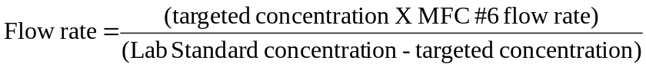Using the last certification data for MFC #1 and #2, determine the flow rates from data taken in previous step. Obtain the last certification data for MFC #6. Using the flow rate for MFC#2, determine the flow setting for the cylinder in cylinder bay #1 to achieve a 0.900 ppb (targeted concentration) concentration. Use the following formulas. Apply this flow rate to get the voltage setting for MFC #6.

      - Type “QUIT” and press the Enter key.

      - On the Source control panel (see Figure 11), flip up switch #1.

      - At the DOS prompt, type “MFCCAL” and press the Enter key.

      - Type “6” (to select MFC#6) and press the Enter key. Type the value determined from step 9.6.3.14 and press the Enter key. Type “10” (for number of samples) and press the Enter key. After samples are taken, press “N” twice.

      - Repeat steps 9.6.3.8 through 9.6.3.10. On step 9.6.3.10, type “40” instead of “10”.Allow 10 minutes to stabilize. Average the last 5 readings of each parameter. Record the average values.

      - Using the previous calibration data for the NO and SO₂ analyzers, determine the NO and SO₂ concentrations for values taken in steps 9.6.3.19 and 9.6.3.13. The difference in SO₂ values is due to NO interference. Using a target value of 0.750 ppb, determine the MFC #6 flow rate as in step 9.6.3.14. Repeat steps 9.6.3.15 through 9.6.3.19 for this new flow rate.

      - Repeat step 9.6.3.20 using the targeted NO concentrations of 600 ppb, 450 ppb, 300 ppb, 150 ppb, and 50 ppb.

      - Type “QUIT” and press the Enter key. At the DOS prompt, type “RSET” and press the Enter key

      - .Remove the Teflon line from the output of MFC #6 and reconnect the stainless steel line to the output of the MFC. Disconnect the other end of the Teflon line from the manifold and plug manifold connection.
      - Shut the cylinder valves on the laboratory standards in bay #1 and #30. At the DOS prompt, type “PURGE” and press the Enter key twice. Type “N” (for nitrogen purge) and press the Enter key. Type “A” (for ambient GAS) and press the Enter key. Wait 30 seconds, then type “30” and press the Enter key. Type “99” and press the Enter key. After done, press the Enter key. Type “N” and press the Enter key. Type “S” and press the Enter key. Wait 30 seconds, then type “1” and press the Enter key. Type “99“ and press the Enter key.

      - After Purge program complete, type “Q” and press the Enter key. At the DOS prompt, type “EXIT” and press the Enter key.

      - Using the computer’s mouse, press the START button. Select the Programs option. Select the Microsoft Excel option. Select the File menu. Select the Open option. Access the K-drive. Select the Qpro folder. Select the Cylinder folder. Select the Cylinder folder. Select the “SO₂ Correction” file and press the Open button.

      - Enter NO concentrations achieved in step 9.6.3.19 through step 9.6.3.21 into cells A2 through A8. Enter the amount the SO₂ changed in cells B2 through B8. Ensure the correlation coefficient in cell E4 is greater than 0.999.

      - Record values in cells E2 and E3. Select the File menu. Select the Exit option. Press the OK button. Press the Start button. Select the Run option. Type “COMMAND” at the input line and press the Enter key.

      - At the DOS prompt, type “BI” and press the Enter key. Scroll down until the entry line for SO₂ correction is selected and enter the values from previous step. Press the Alt and F keys simultaneously. Press the X key. Select the Save option and press the Enter key.

      - At the DOS prompt, type”MAKE_GAS” and press the Enter key. The gas SO₂ correction factor has now been incorporated into the program. Make reference to the calculation in the Gas Log Book.

- REFERENCES

  - EPA Traceability protocol for Assay and Certification of Gaseous Calibration Standards. EPA-600/R-97/121, September 1997, U.S. Environmental Protection Agency (MD-47), National Exposure Research Laboratory, Human Exposure and Atmospheric Sciences Division, Research Triangle Park, NC 27711.

  - User’s Manual for Porter Thermal Mass Flowmeter and Thermal Mass Flow Controller. Porter Instrument Company, Inc. P.O. Box 326, Township Line Road, Hatfield, PA 19440.

APPENDIX A
DATASHEETS

